**SAP BW/BO Exercise**

**Exercise#: HANA Data Modeling Part 1(Attribute View)**

**Student Name: Nupur Ray Student Id: nxr163130**

**Date: 21/09/2016 HANA Login Id: GBI_345**

**Note: You must use the following conventions to name objects/systems created in this exercise.**

**Replace S with the semester**

**A for Fall**

**B for Spring**

**C for Summer**

**Replace XX with the two-character year (ex. 20 for 2020)**

**Replace YYY with your Student ID (ex. 147 if you were issued ID GBI_147)**

**Please use the screenshots ONLY as a reference. The instructions have to be followed AS-IS.**

**Objective**

The sales department has provided you three Excel spreadsheets that include sales data on customers, products and sales transactions of the last five years.

|  |  |
| --- | --- |
| **Customer data (excerpt)** | **Product data (excerpt)** |
| **Sales transaction data** | |

You choose a bottom-up approach and develop your data model based on the available source data using SAP HANA. Furthermore, you refine the data model by implementing some additional requirements of the sales department, e.g. the modeling of calculated key figures that are not included in the source data.

In a final step, you use SAP Business Objects Explorer to demonstrate the data analysis and data exploration capabilities provided by the solution.

1. Create the database tables

At first you create the database tables in SAP HANA. These tables will serve as data foundation for the information models (views) that will be created in a later step.

As indicated in the business scenario, you need to create three tables, one for sales transaction data, one for the customer master data, and one table for product master data.

Remark: You create all database tables in the database schema GBI_YYY where YYY defines the student number provided.

* 1. Open SAP HANA Studio

Go to ‘SAP HANA Modeler’ prospective

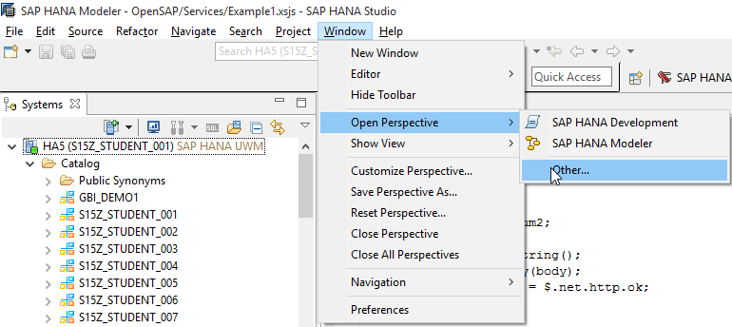

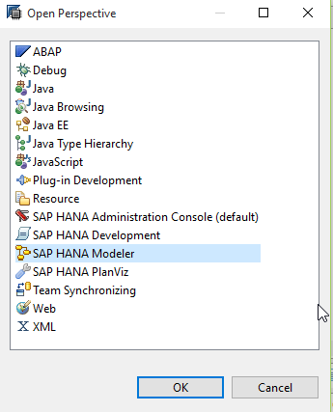

REMARK: Make sure you use your designated schema in the instructions

* 1. Create a database table for the customer master data

1. Open schema corresponding to your user name (GBI_YYY) and go to “Tables” folder:

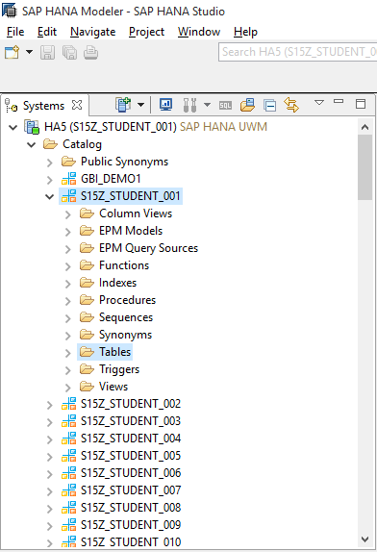

1. Right click on Table folder and enter Table Name, Field Name, SQL Data Type and Dim (Field Length) as given below:

Use following details to create the table:

Table name: CUSTOMER_ATTR_YYY

Table type: Column Store

Add following columns to the table:

|  |  |  |  |
| --- | --- | --- | --- |
| Name | Key | Data type | Length (Dim) |
| CUSTOMER_ID | X | VARCHAR | 20 |
| CUSTOMER_NAME |  | VARCHAR | 100 |
| COUNTRY_CODE |  | VARCHAR | 3 |
| CUSTOMER_SEGMENT_ID |  | VARCHAR | 6 |
| PROVINCE |  | VARCHAR | 30 |
| REGION |  | VARCHAR | 30 |
| VALID_TO |  | DATE |  |
| VALID_FROM |  | DATE |  |
| LANGU | X | VARCHAR | 1 |

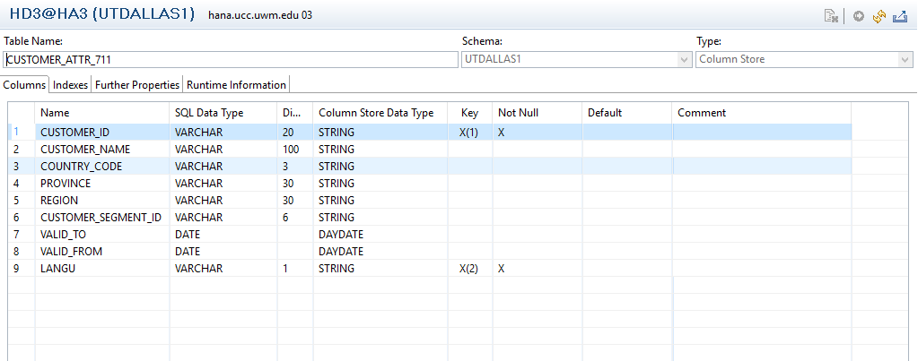

1. Create the table using the Execute button. Look for the success message.

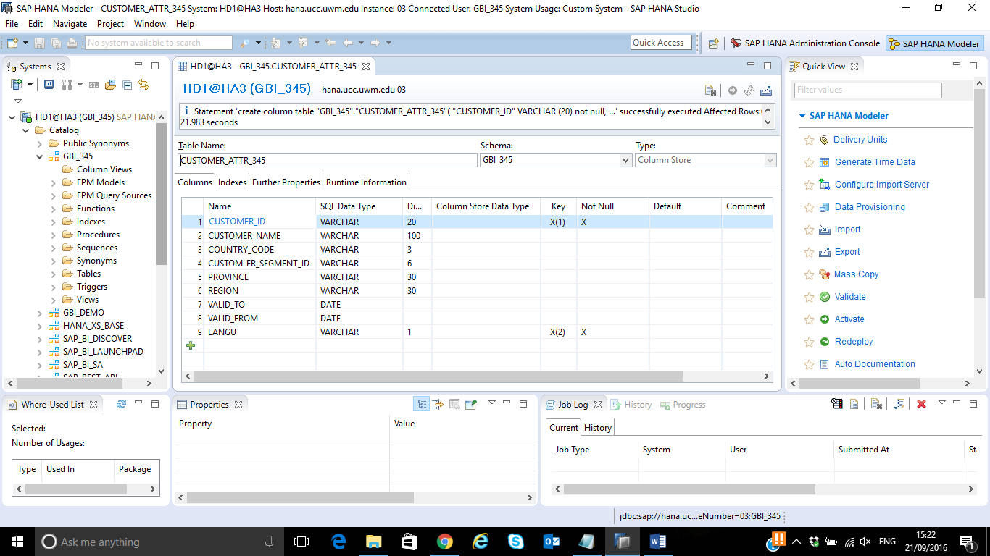

1. Right click on Table folder and enter Table Name, Field Name, SQL Data Type and Dim (Field Length) as given below:

Use following details to create the table:

Table name: CUSTOMER_SEGMENT_ATTR_YYY

Table type: Column Store

Add following columns to the table:

|  |  |  |  |
| --- | --- | --- | --- |
| Name | Key | Data type | Length (Dim) |
| CUSTOMER_SEGMENT_ID | X | VARCHAR | 6 |
| CUSTOMER_SEGMENT_NAME |  | VARCHAR | 20 |
| LANGU | X | VARCHAR | 1 |

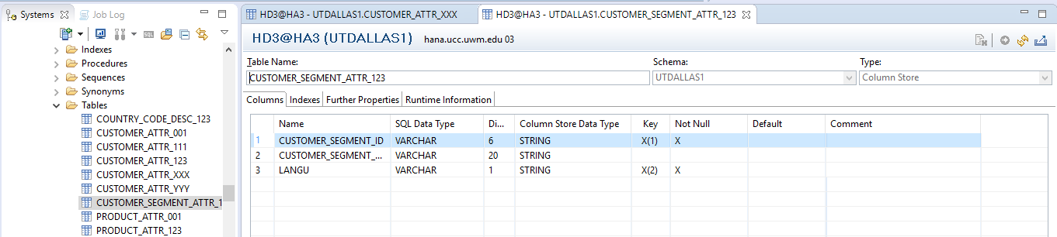

1. Create the table using the Execute button. Look for the success message.

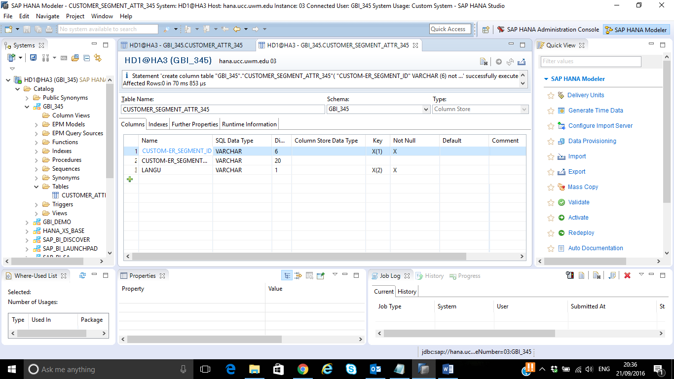

1. Right click on Table folder and enter Table Name, Field Name, SQL Data Type and Dim (Field Length) as given below:

Use following details to create the table:

Table name: COUNTRY_CODE_DESC_YYY

Table type: Column Store

Add following columns to the table:

|  |  |  |  |
| --- | --- | --- | --- |
| Name | Key | Data type | Length (Dim) |
| COUNTRY_CODE | X | VARCHAR | 3 |
| COUNTRY_NAME |  | VARCHAR | 20 |
| CURRENCY |  | VARCHAR | 3 |
| CONVERSION_RATE |  | DECIMAL | 17,2 |
| LANGU | X | VARCHAR | 1 |

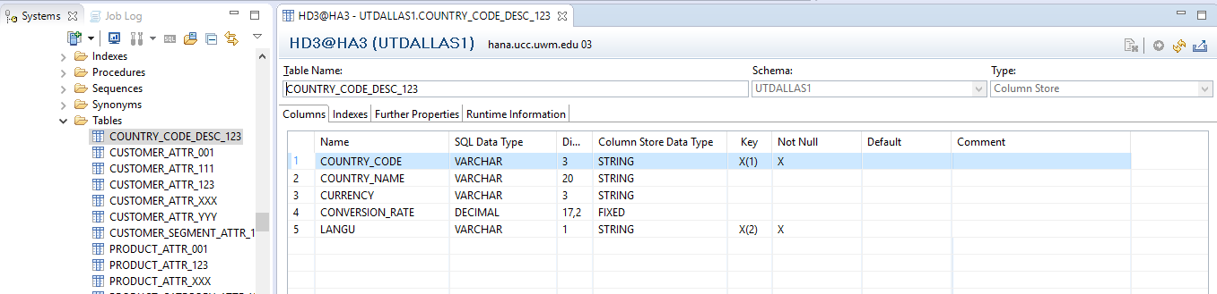

1. Create the table using the Execute button. Look for the success message.

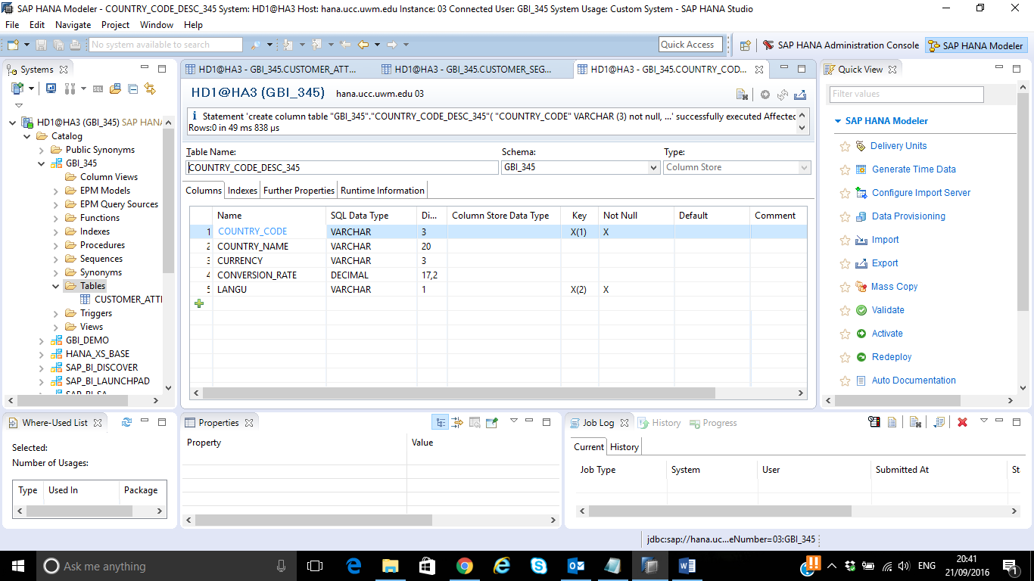

* 1. Create database tables for the product master data. You have been given the product data file. Later in the exercise, you will be normalizing the data and segregate it into 4 different tables below:

|  |
| --- |
| PRODUCT_ATTR_XXX |
| PRODUCT_LINE_ATTR_XXX |
| PRODUCT_CATEGORY_ATTR_XXX |
| PRODUCT_SUBCATEGORY_ATTR_XXX |

Follow steps given in above step and create product master tables:

Use following details to create the table:

1. Table name: PRODUCT_ATTR_YYY

Table type: Column store

Add following columns to you table:

|  |  |  |  |
| --- | --- | --- | --- |
| Name | Key | Data type | Length (Dim) |
| PRODUCT_ID | X | VARCHAR | 18 |
| PRODUCT_NAME |  | VARCHAR | 100 |
| PRODUCT_LINE_ID |  | VARCHAR | 6 |
| PRODUCT_CATEGORY_ID |  | VARCHAR | 6 |
| PRODUCT_SUBCATEGORY_ID |  | VARCHAR | 6 |
| PRODUCT_CONTAINER |  | VARCHAR | 15 |
| PROFIT_MARGIN |  | DECIMAL | 17,2 |
| UNIT_PRICE |  | DECIMAL | 17,2 |
| LANGU | X | VARCHAR | 1 |

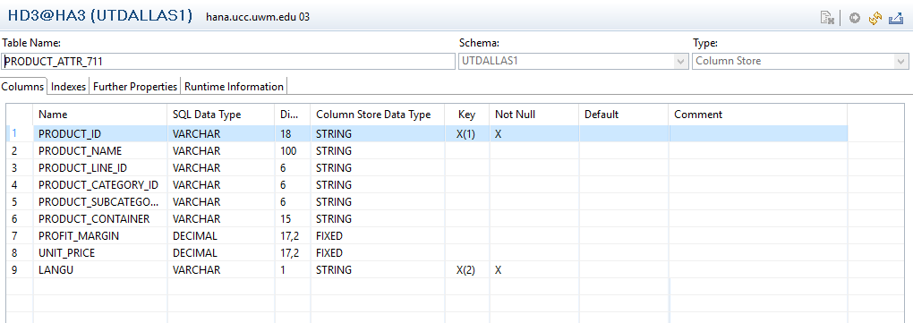

*Note: In case you are not able to see the newly created table in the folder, right click on tables folder and click on ‘Refresh’.*

1. Table name: PRODUCT_LINE_ATTR_YYY

Table type: Column store

Add following columns to you table:

|  |  |  |  |
| --- | --- | --- | --- |
| Name | Key | Data type | Length (Dim) |
| PRODUCT_LINE_ID | X | VARCHAR | 10 |
| PRODUCT_LINE_DESC |  | VARCHAR | 30 |
| LANGU | X | VARCHAR | 1 |

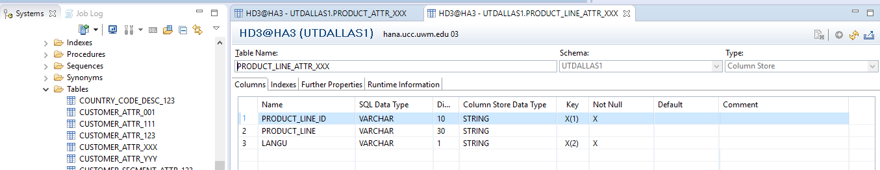

1. Table name: PRODUCT_CATEGORY_ATTR_YYY

Table type: Column store

Add following columns to you table:

|  |  |  |  |
| --- | --- | --- | --- |
| Name | Key | Data type | Length (Dim) |
| PRODUCT_CATEGORY_ID | X | VARCHAR | 10 |
| PRODUCT_CATEGORY_DESC |  | VARCHAR | 30 |
| LANGU | X | VARCHAR | 1 |

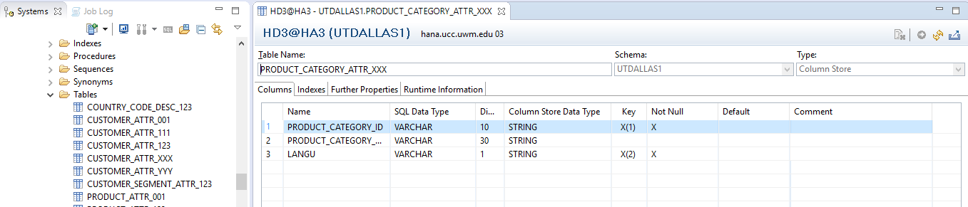

1. Table name: PRODUCT_SUBCATEGORY_ATTR_YYY

Table type: Column store

Add following columns to you table:

|  |  |  |  |
| --- | --- | --- | --- |
| Name | Key | Data type | Length (Dim) |
| PRODUCT_SUBCATEGORY_ID | X | VARCHAR | 10 |
| PRODUCT_SUBCATEGORY_DESC |  | VARCHAR | 50 |
| LANGU | X | VARCHAR | 1 |

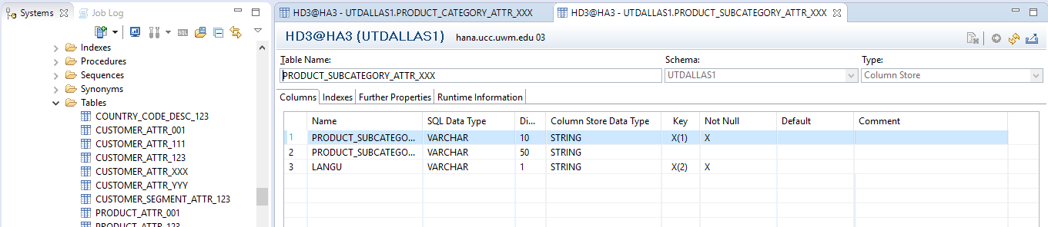

* 1. Create a database table for the sales transaction data

Use following details to create the table:

Table name: SALES_YYY

Table type: Column store

Add following columns to your table:

|  |  |  |  |
| --- | --- | --- | --- |
| Name | Key | Data type | Length (Dim) |
| ORDER_ID | X | VARCHAR | 10 |
| ORDER_DATE |  | DATE |  |
| ORDER_PRIORITY |  | VARCHAR | 15 |
| ORDER_QUANTITY |  | INTEGER |  |
| NET_SALES_REVENUE |  | DECIMAL | 17,2 |
| SHIP_MODE |  | VARCHAR | 30 |
| SHIPPING_COST |  | DECIMAL | 17,2 |
| PRODUCT_ID |  | VARCHAR | 18 |
| CUSTOMER_ID |  | VARCHAR | 20 |

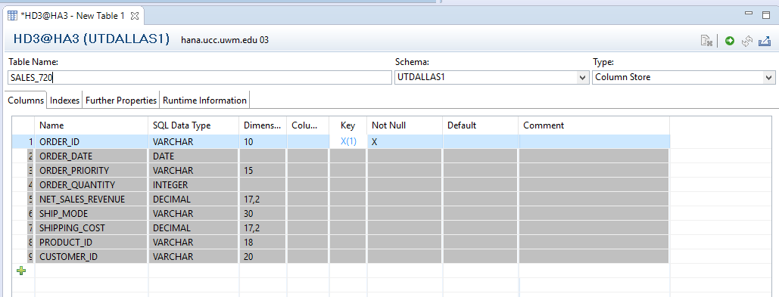

*Note: Make sure you include all the fields mentioned in the table as the same data tables will be used further for reporting.*

1.4 Question:

Paste the screenshot of SALES_YYY table definition created (Right click on the table and click on ‘Open Definition’)

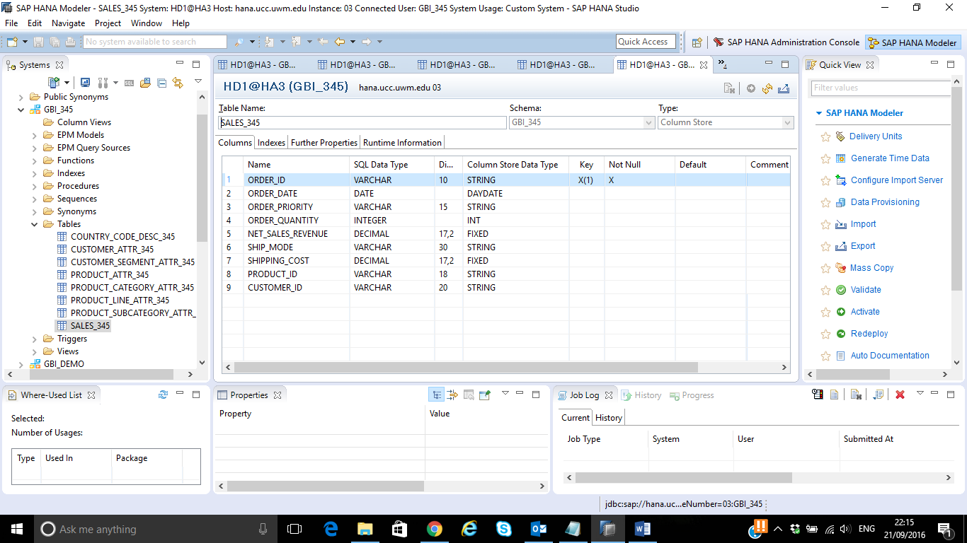

Similarly, paste the screenshot of PRODUCT_ATTR_YYY tables created

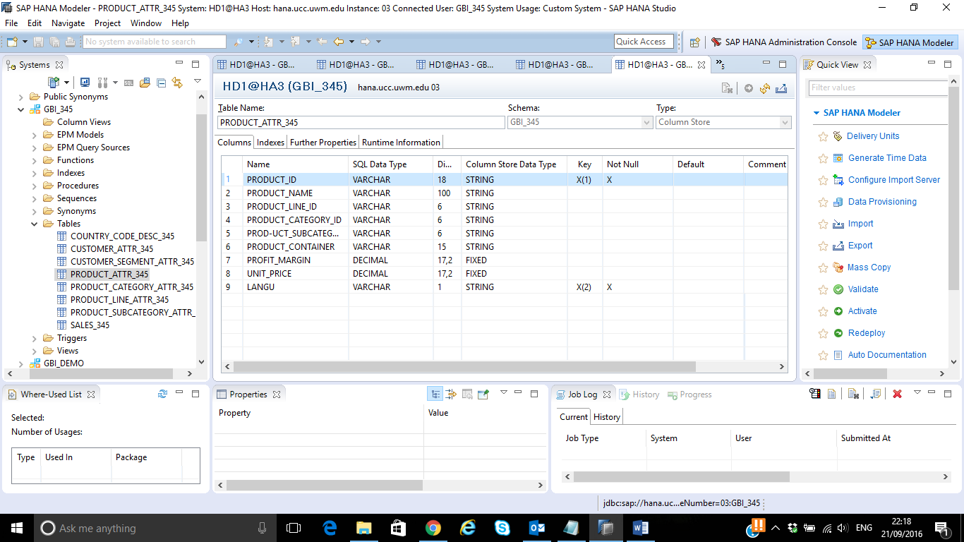

Paste the screenshot of PRODUCT_LINE_ATTR_YYY tables created:

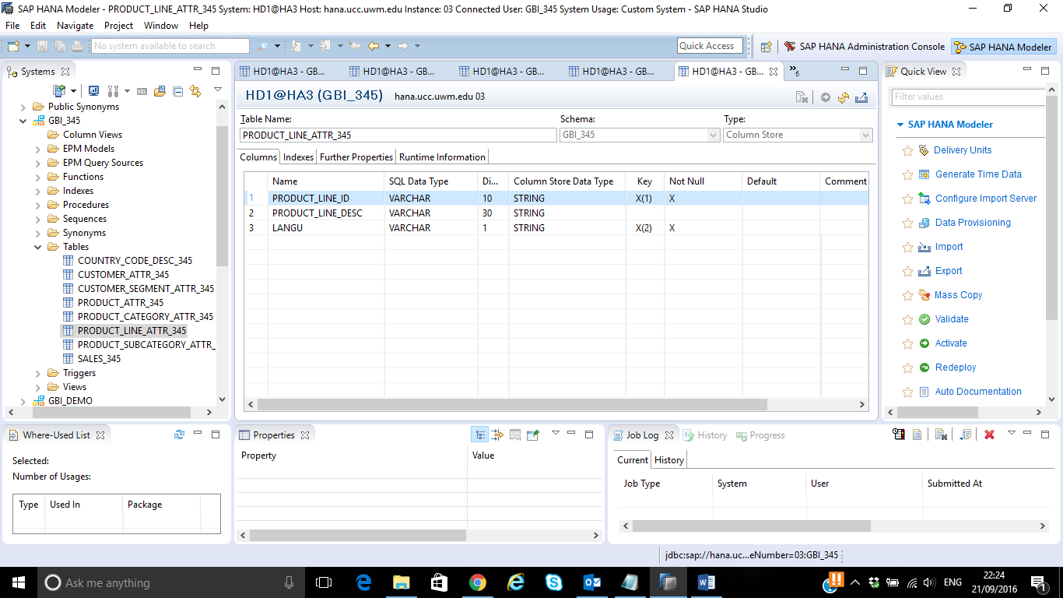

Paste the screenshot of PRODUCT_CATEGORY_ATTR_YYY tables created:

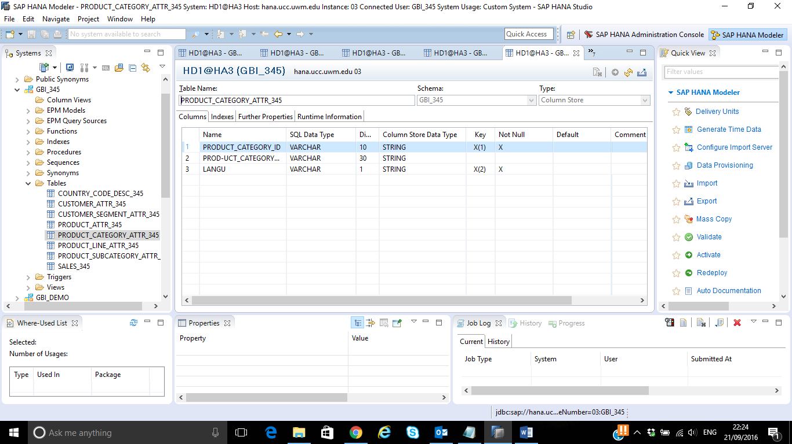

Paste the screenshot of PRODUCT_SUBCATEGORY_ATTR_YYY tables created:

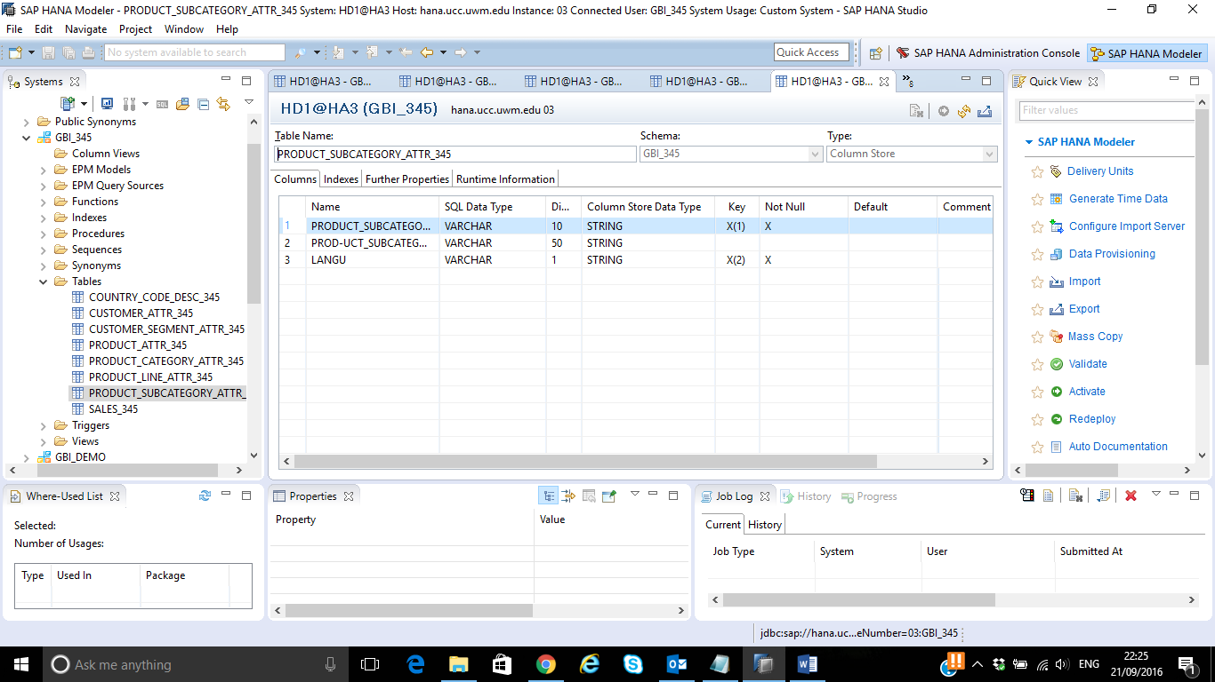

Paste the screenshot of CUSTOMER_ATTR_YYY tables created:

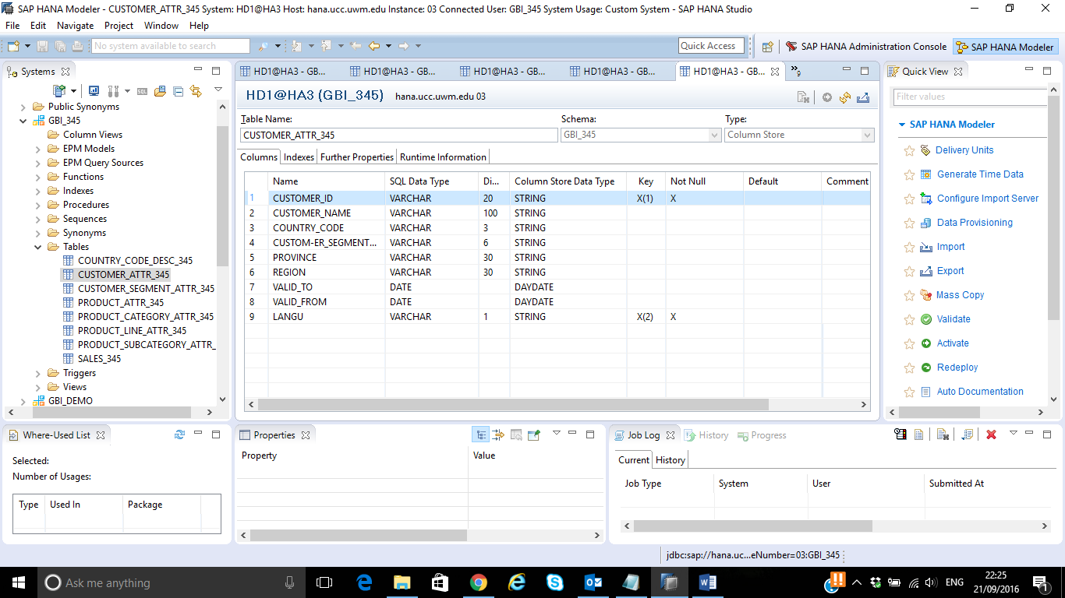

Paste the screenshot of CUSTOMER_SEGMENT_ATTR_YYY tables created:

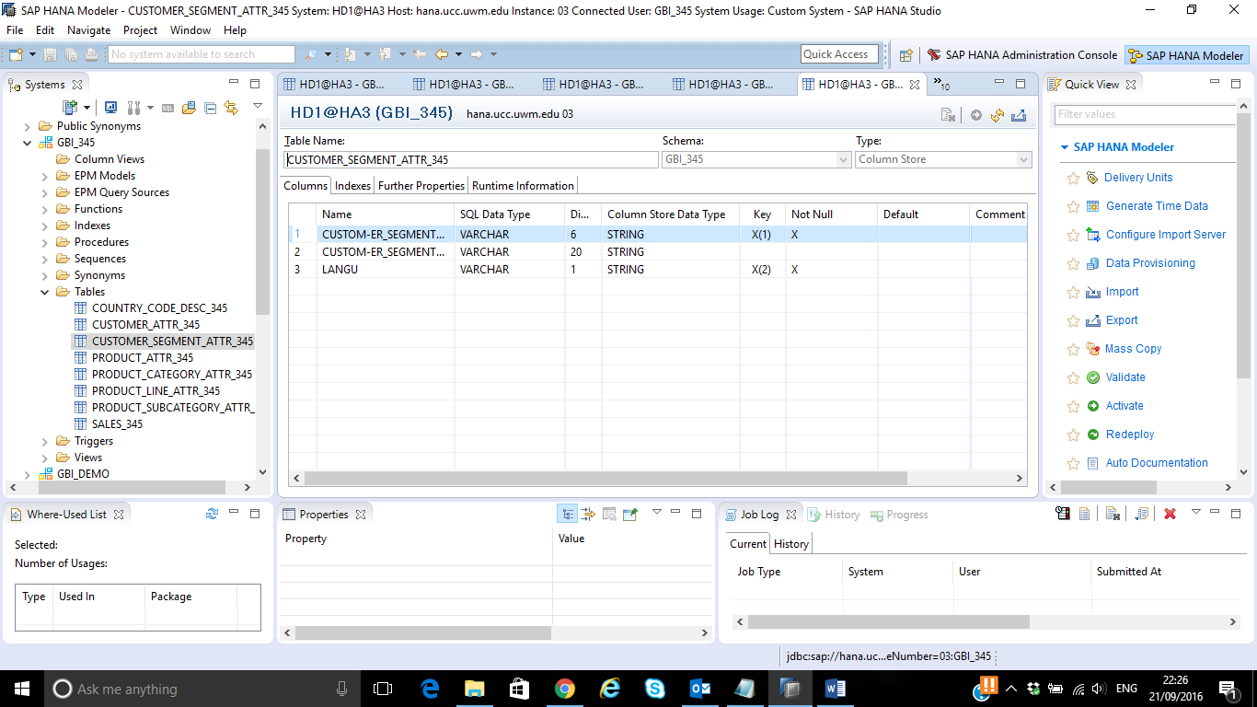

Paste the screenshot of COUNTRY_CODE_DESC_YYY tables created:

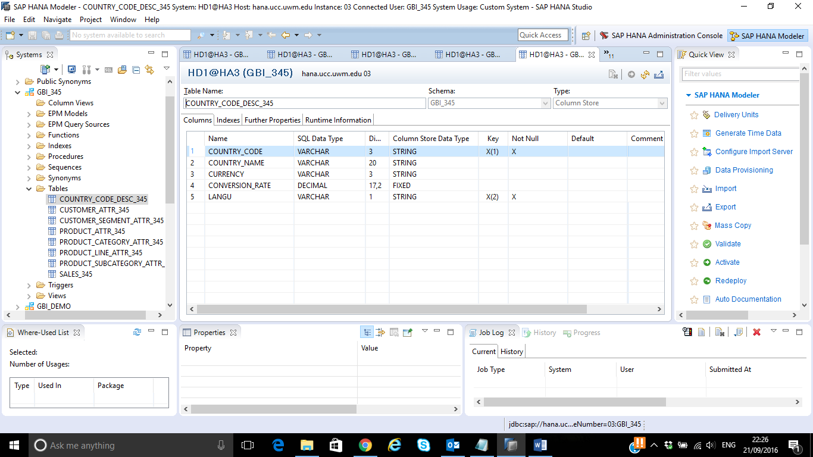

Data provisioning

There are three flat files used for these tasks: Customer.csv, Product.csv and Salesdata.csv.

Database tables will be populated via HANA Studio Each file is populating the corresponding table in the SAP HANA database. The files are provided along with the assignment and can be loaded directly from there.

The figure below shows the scenario you are going to implement in this task. However, you won’t be using SAP BODS as shown in the picture, flat files will be imported directly through the import feature of HANA Studio.

**Table *Customer Attributes***

CUSTOMER_ATTR_***YYY***

Flat file format   
***Customer   
***

**Table *Product Attributes***

PRODUCT_ATTR_***YYY***

**Table *Sales***

SALES_***YYY***

Flat file format   
***Product  
 ***

Flat file format   
***Sale*s**

**Data flow**

**Data flow**

**Data flow**

* 1. Direct Flat File Import
  2. Select the HANA System in the Navigator and click on File → Import

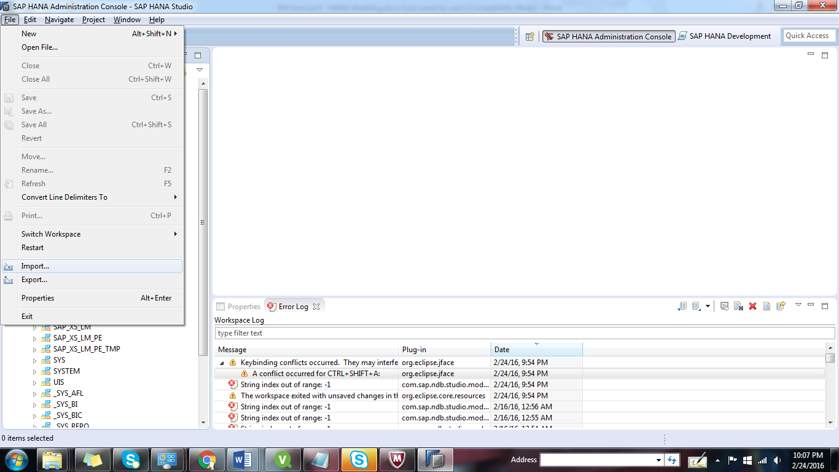

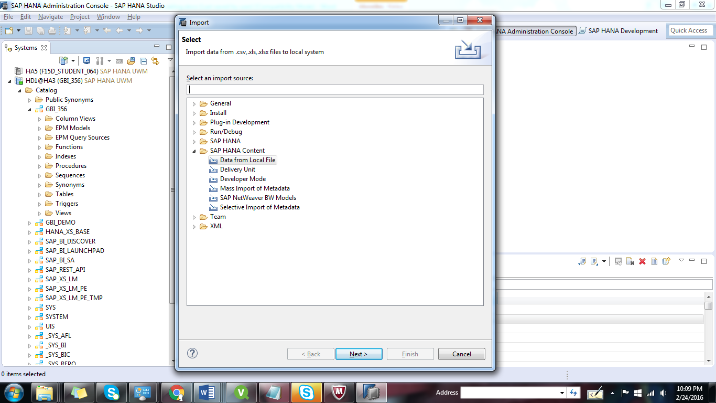Select SAP HANA Content → Data from Local File and click on Next.

Select the system in which you want to import the flat file and click on Next.

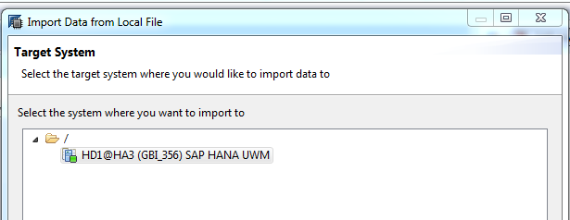

2.3 Select Flat File

Download dataset files provided in eLearning along with the exercise.

Click on Browse to the select the files that you have saved in previous step.

After you selected the file, change the different properties of the file import to match the properties of the CSV-File (as shown in the screenshot).

If you create a new table, make sure that you selected your schema (GBI_S##) and that you assigned a proper table name. In this scenario, since you have already created a target table, you can select it by selecting the Existing radio button and clicking on Select Table.

Let us start with the Customer data file.

Note: Select the separator as comma, ‘,’

In case you want to open the data files, please open with Notepad (in Windows) or TextEdit (in Apple OSX). DO NOT open in excel. Also, DO NOT save the files. If you do same then it will create reformatting. You will then need to download the files again.

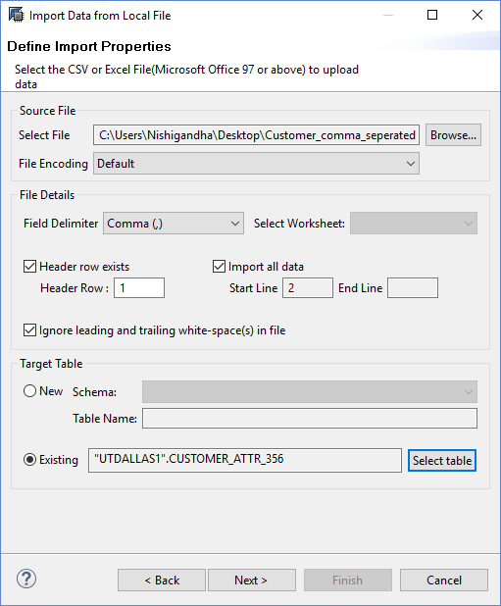

**2.4 Manage Table Definition and Data Mappings**

In this step, you can define the properties of the different columns in the target database (in case you are creating a new one), for example column names, data types, keys etc. as well as the mapping of the different file fields to the table columns.

Drag & drop each source field from .csv file to the corresponding target field of Target table as seen in the screenshot.

*Note: Make sure that you select the file type properly by checking the look of the data*.

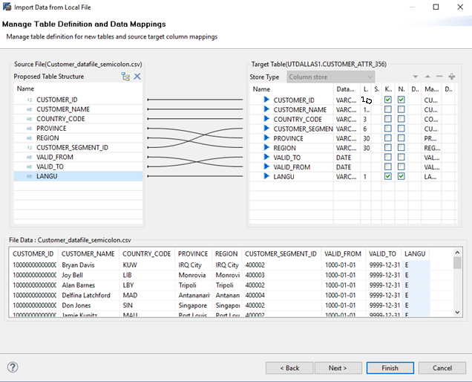

2.5 After you have pressed FINISH, you will be directed to the job log.

If the batch job has been performed successfully, you should see a corresponding message in the bottom line of the job log as seen in the screenshot.

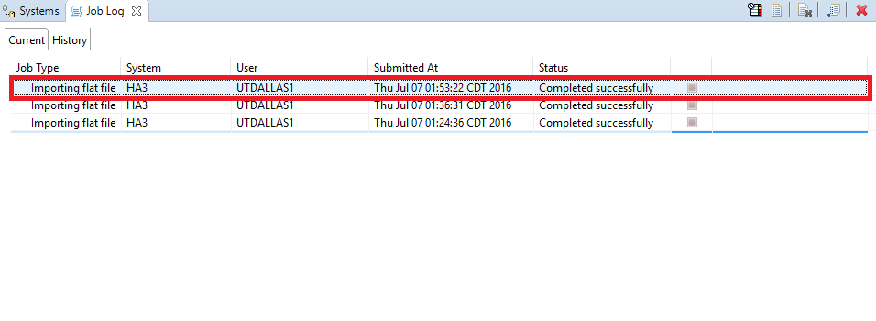

Screenshot:

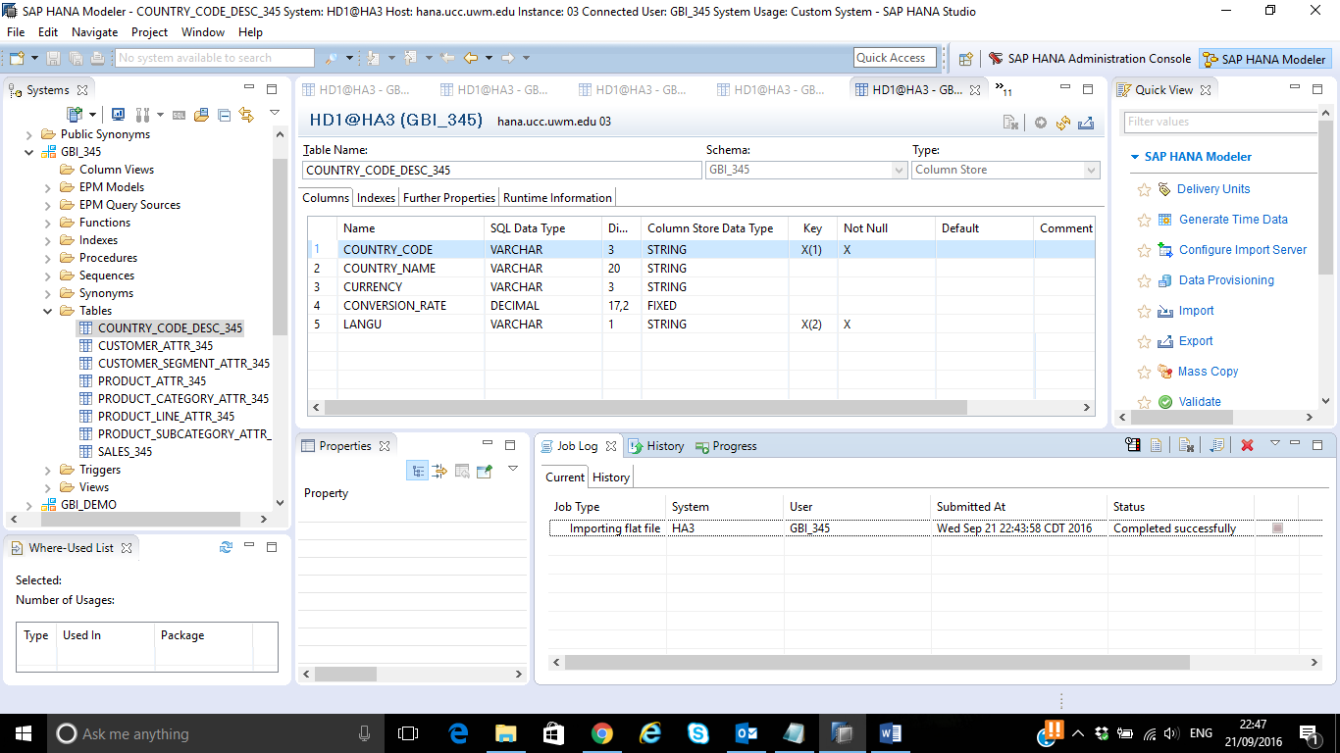

Similarly, follow the steps from 2.2 to 2.5 for Product data files. But before that, please remember to create four different files as follows by referring to the Product data file given.

**Product Line data file:** Create a .csv file named ‘Product_Line.csv’ with data as shown below.

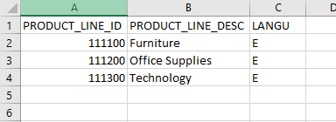

**Product Category data file:** Create a .csv file named ‘Product_Category.csv’ with data as shown below.

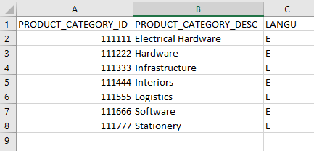

**Product Subcategory data file:** Create a .csv file named ‘Product_Subcategory.csv’ with 0000000data as shown below.

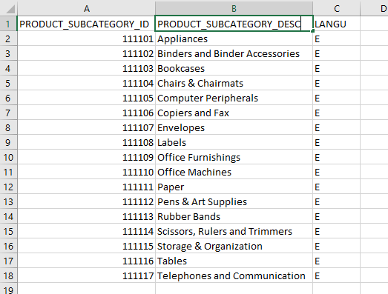

**Product data file:** Now, in the Product data file replace Product_Line_Desc, Product_Category_Desc and Product_Subcategory_Desc with Product_Line_ID, Product_Category_ID and Product_Subcategory_ID respectively.

**Save** it as **Product_datafile.csv.**

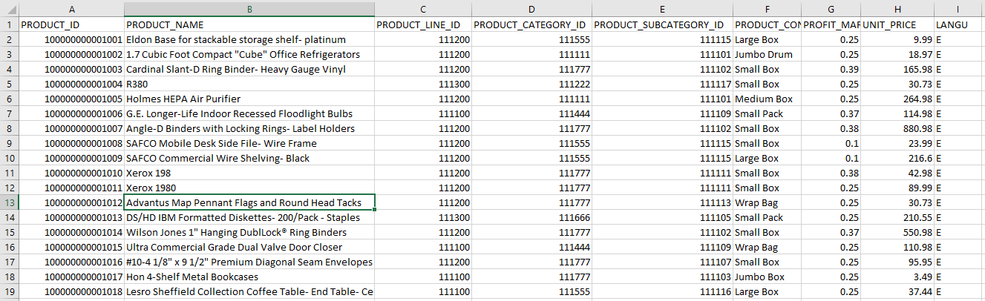

For reference, the screenshots will look as follows:

Product File:

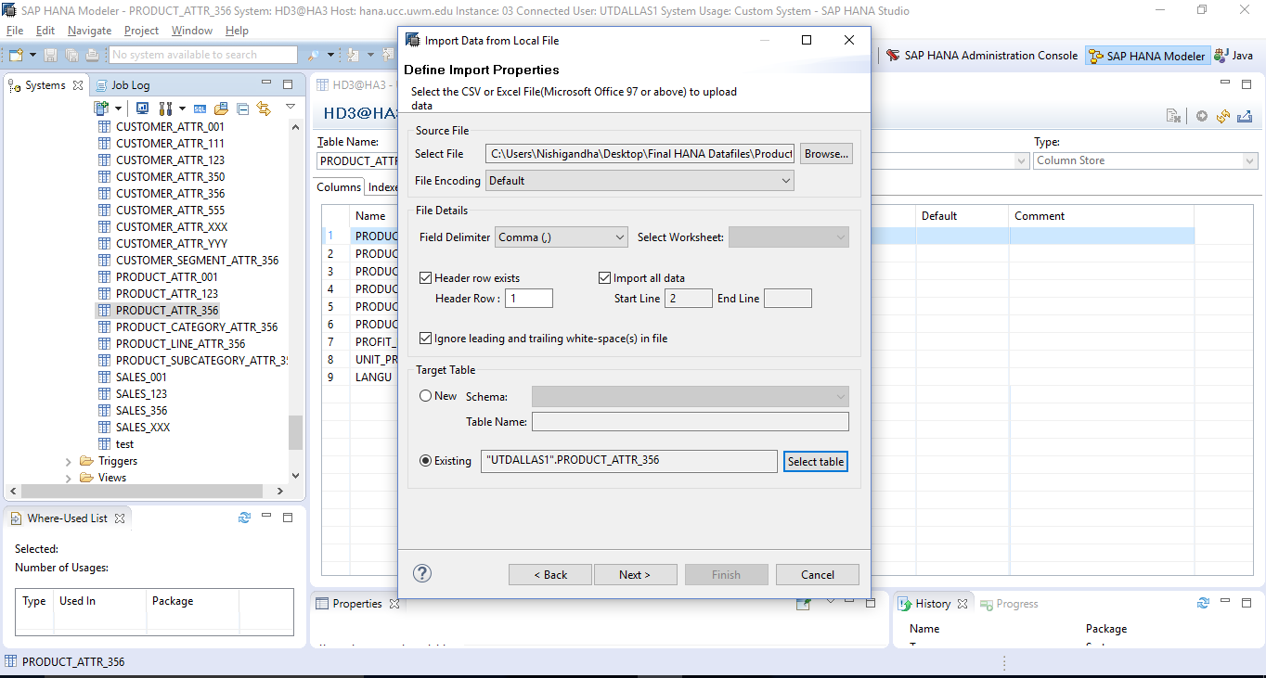

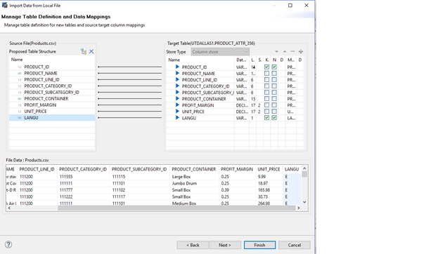

Sales File:

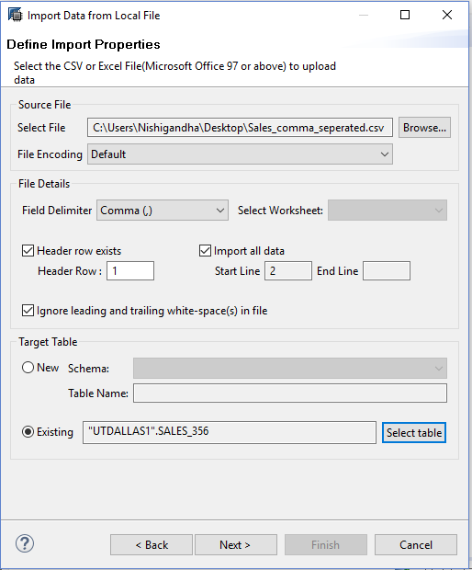

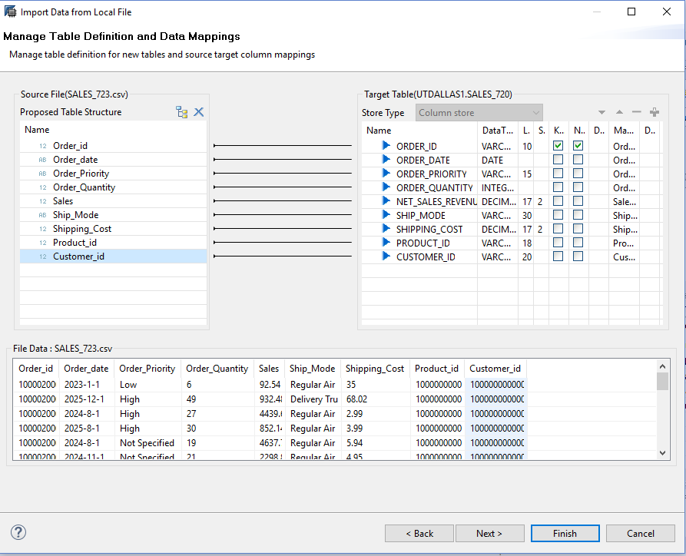

Similarly load data into,

COUNTRY_CODE_DESC_XXX,

CUSTOMER_SEGMENT_ATTR_XXX,

PRODUCT_LINE_ATTR_XXX,

PRODUCT_CATEGORY_ATTR_XXX,

PRODUCT_SUBCATEGORY_ATTR_XXX.

2.6 Open the SAP HANA Studio

Navigator View → Catalog → GBI_YYY → Tables → CUSTOMER_ATTR_YYY → Right click→ Open Data Preview.

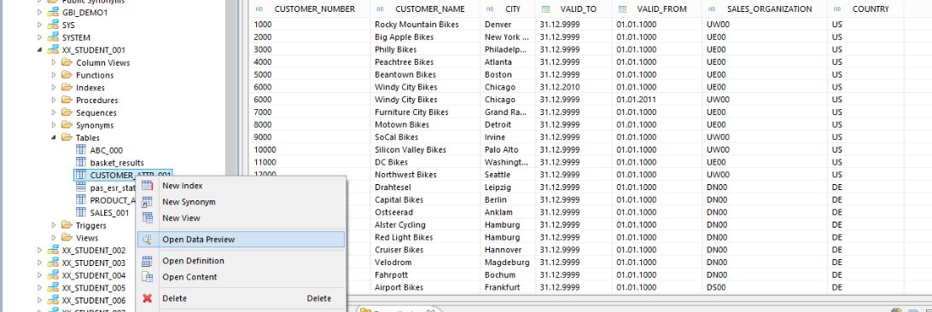

*Note: If the data doesn’t look like what you expected please go back and check the file type.*

**Question:**

*2.7: Paste your screenshot for all the data preview tables:*

**1. Customer**

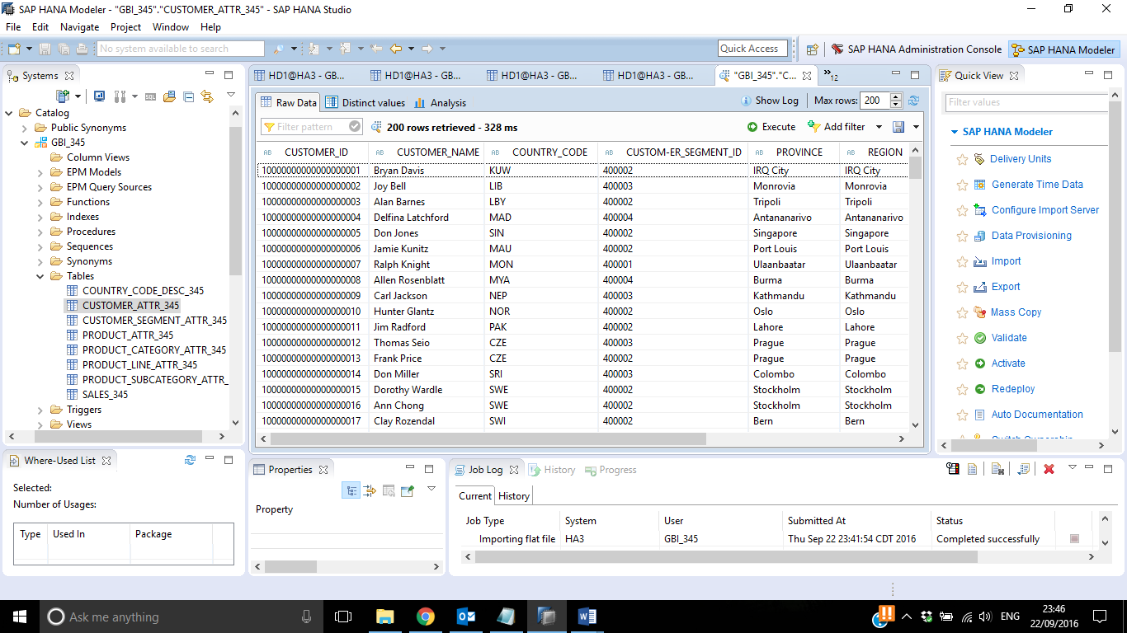

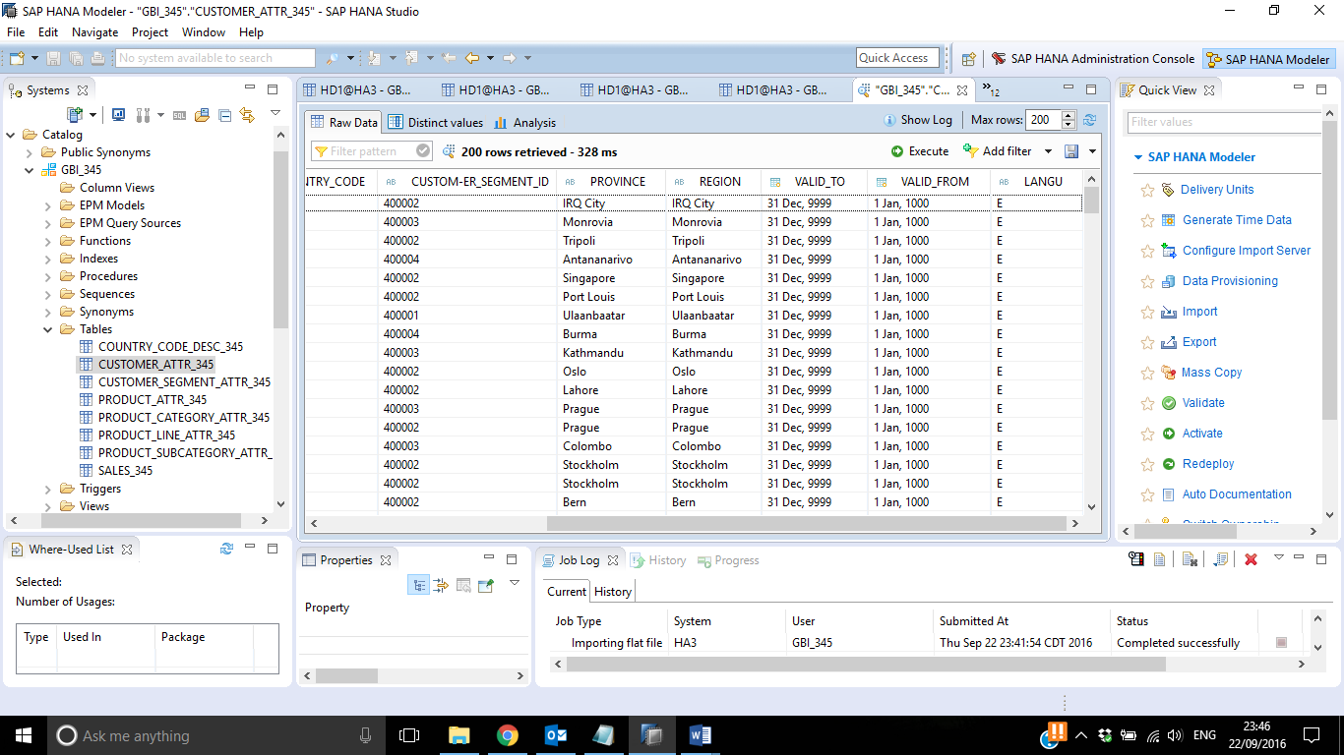

1. Country Code Description

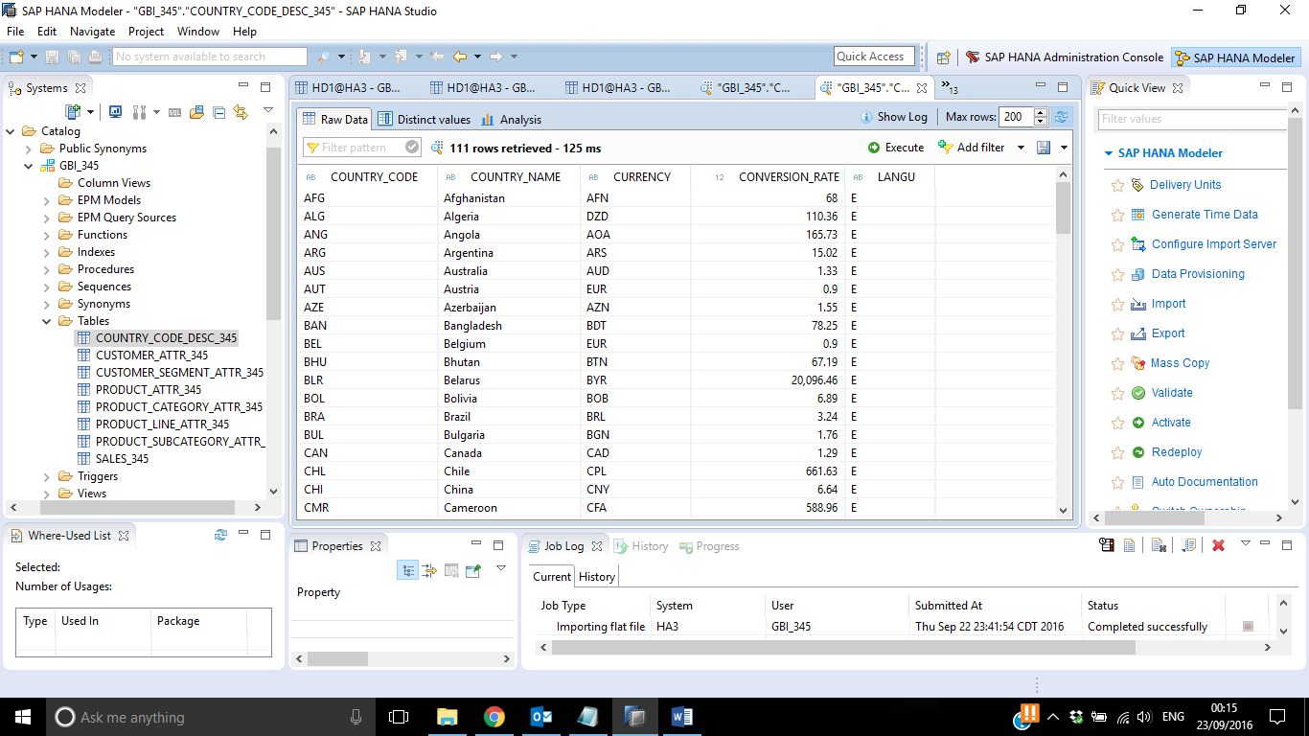

1. Customer Segment

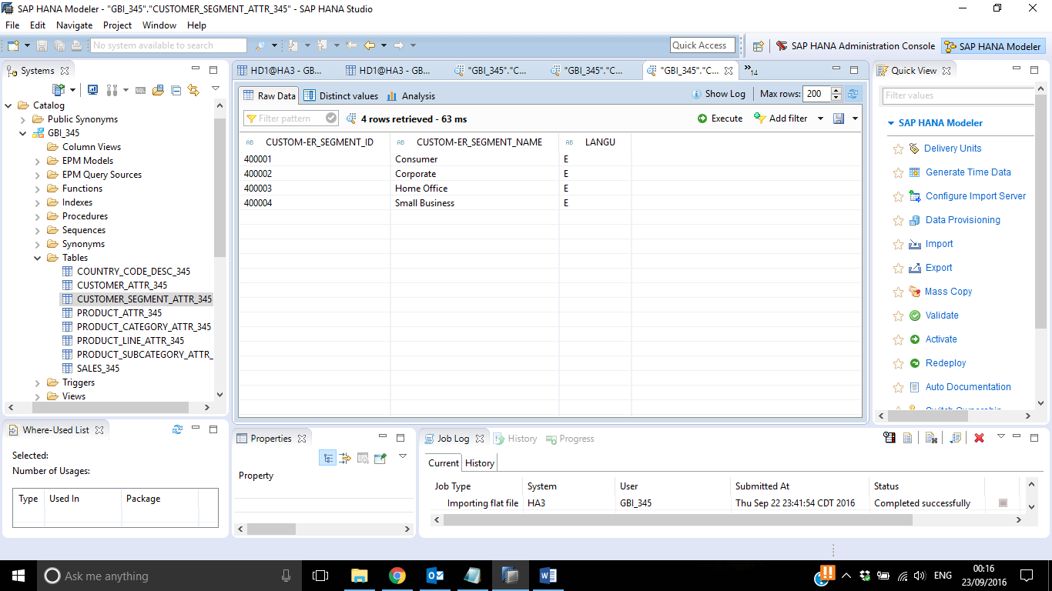

1. Product

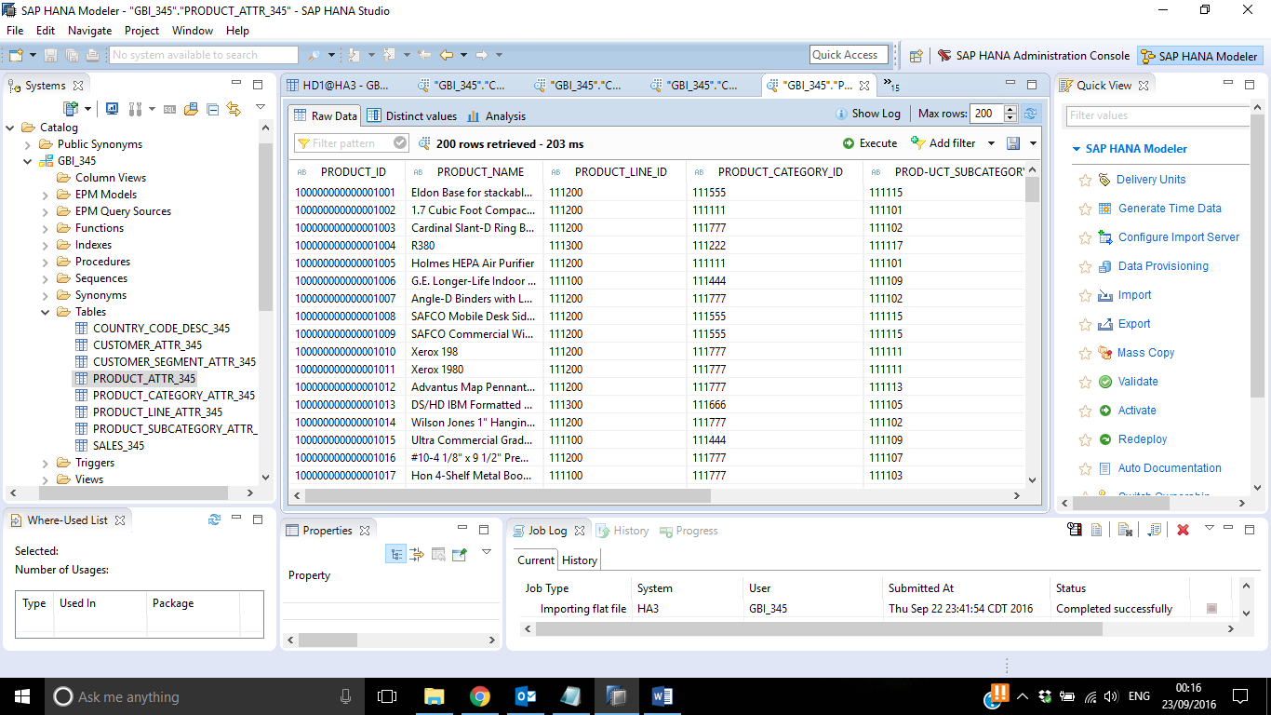

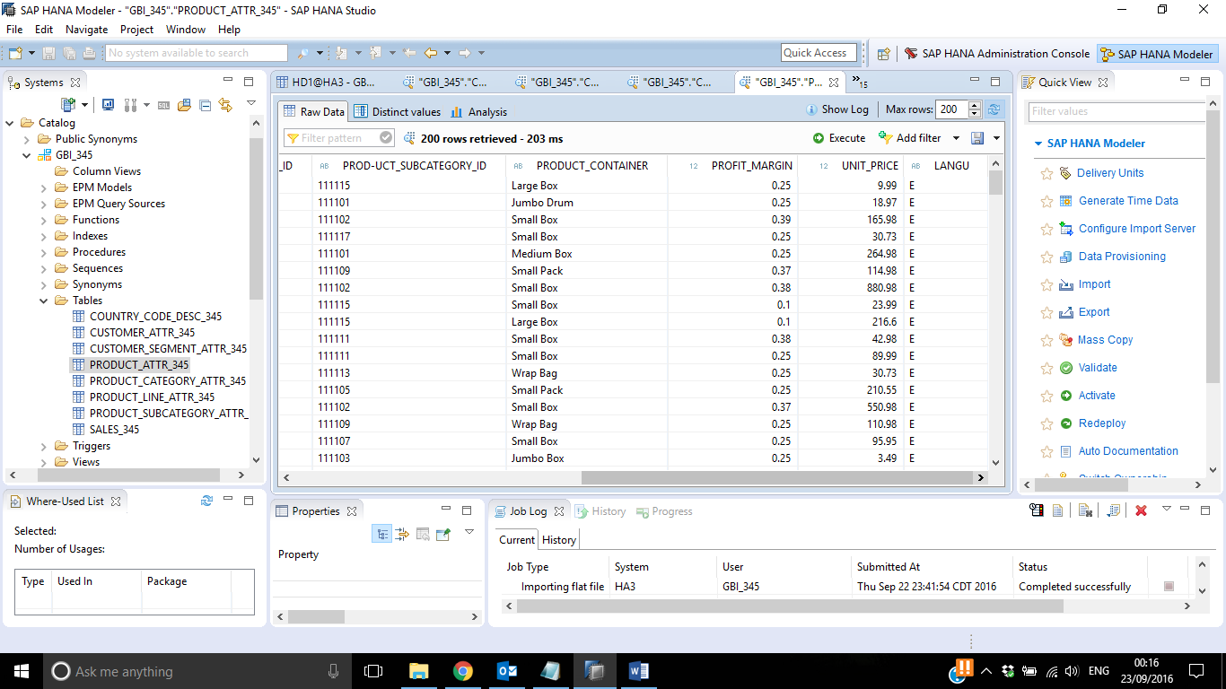

1. Product Line

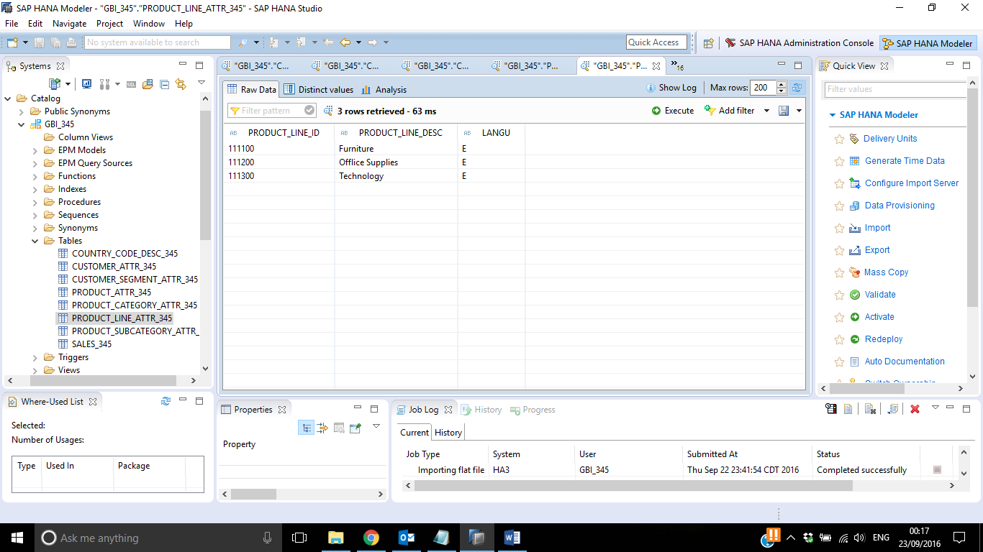

1. Product Category

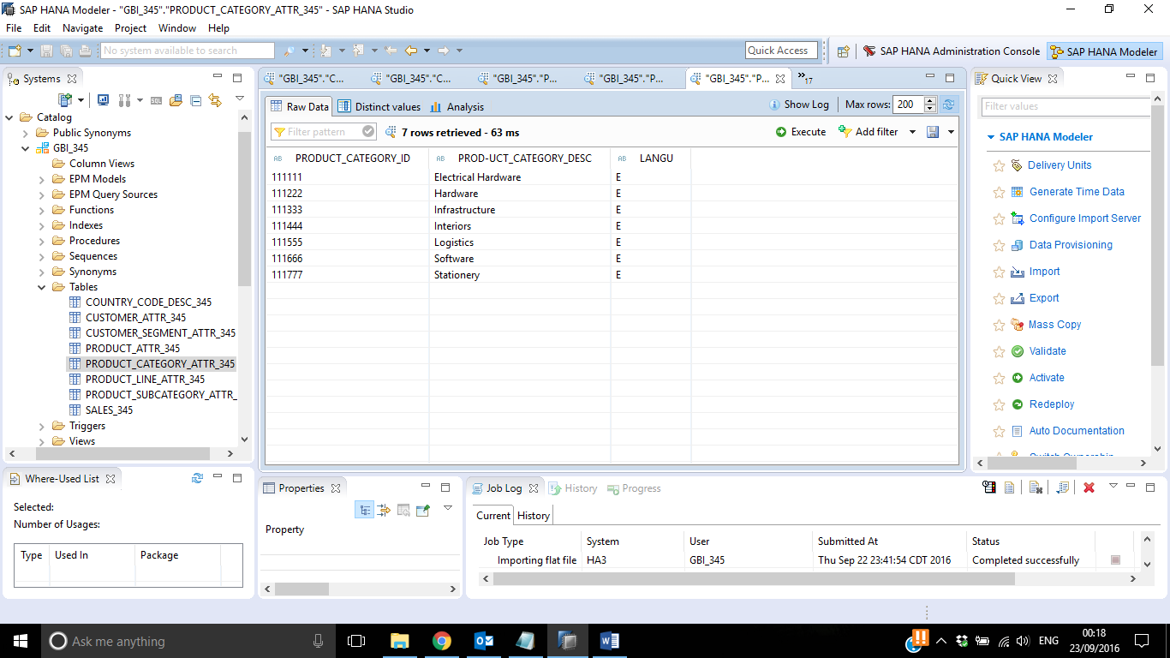

1. Product Subcategory

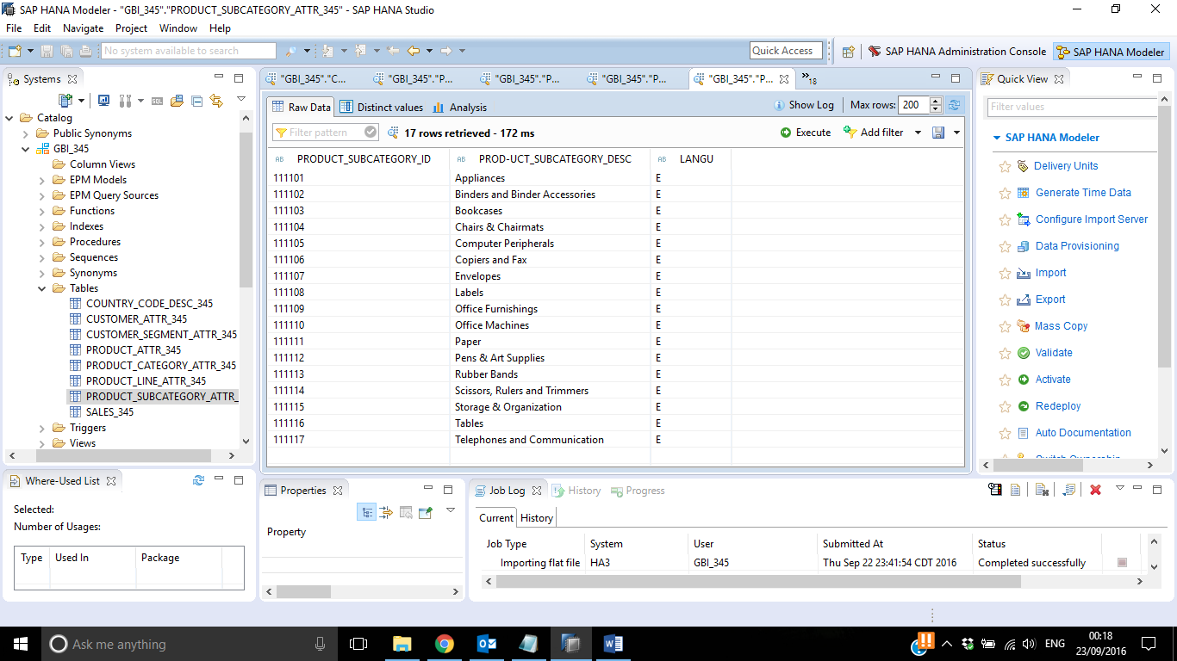

1. Sales

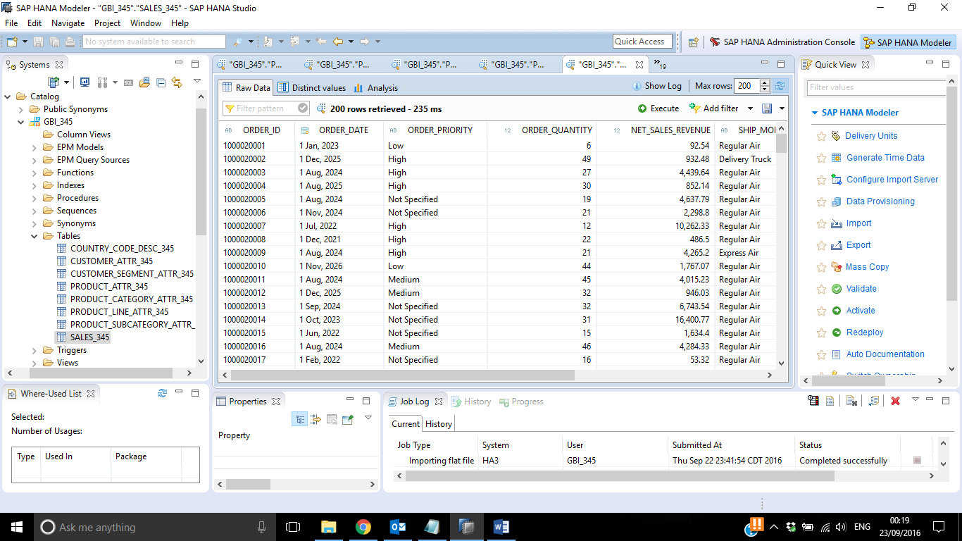

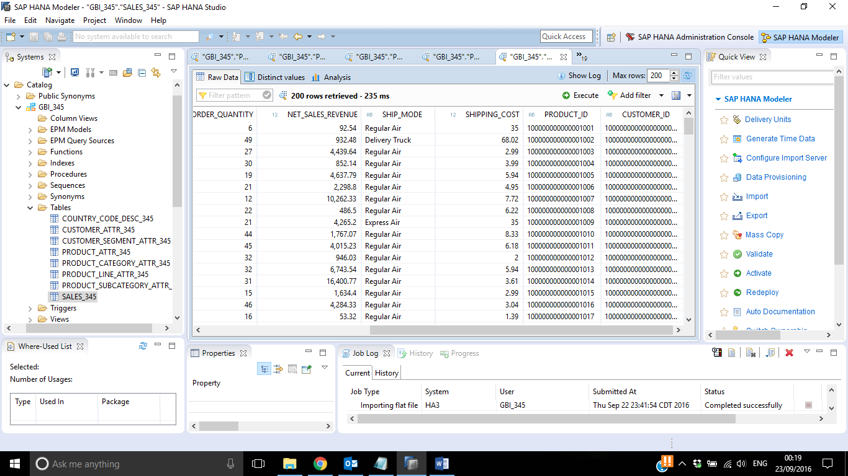

1. Create an attribute view for customer data

Your previously created customer table includes various attributes that are related to customers. For some of these attributes, e.g. country and customer segment, the table includes only keys, but no textual descriptions. Descriptions for these fields are kept in separate text tables.

**Example:** In the Customer attributes table, the field COUNTRY includes only country codes like “USA” for United States of America. The description United States of America is stored in text table COUNTRY_CODE_DESC.

To merge this data, you create an attribute view. The attribute view joins the Customer attributes table with the text tables for country code and customer segment, using a text join.

Furthermore, the customer table includes not only current but also historical customer data. Historical customer data has a valid-to-date before 9999-12-31. To suppress any historical data (valid-to-date < 9999-12-31) you set a filter in this view.

* 1. Open the modeler perspective in the SAP HANA Studio

Window → Open Perspective → Modeler

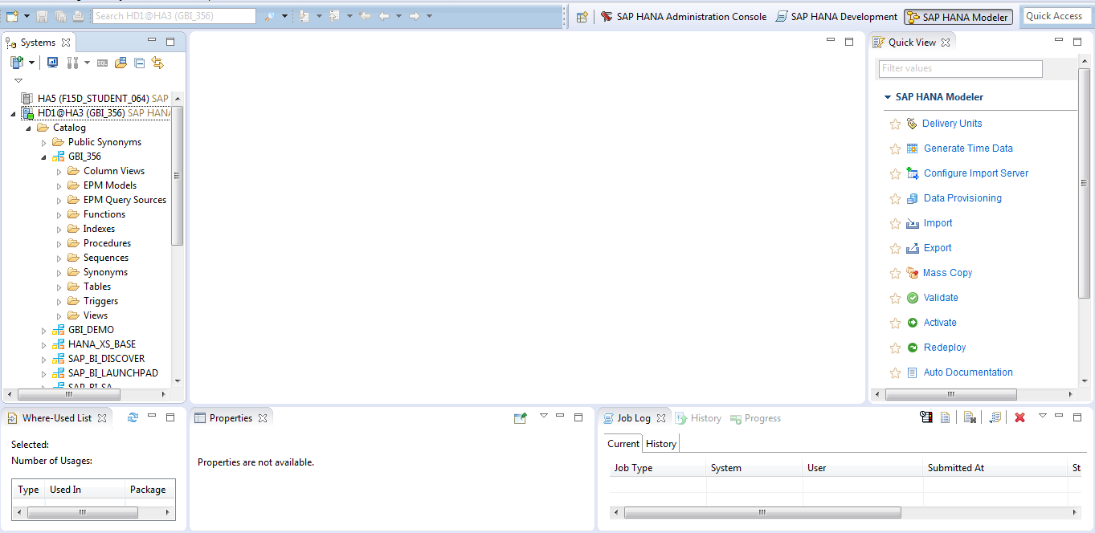

* 1. Create a new package to group the views that you will create in the following steps

You have to create the package under your root package SXX, which represents the semester and year you are taking the course.

Use following details to create the package:

Name: GBI_345.SXX.GBI_YYY

Description: Package Student YYY

Original Language: English

Person Responsible: GBI_YYY

Go to the Navigator View and follow the below path to create package.

Content → Right click → New → Package

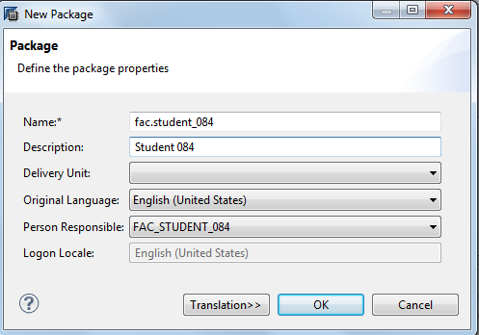

Press OK

* 1. In your package, create an attribute view for the customer data

Use following details to create the initial view:

**Package name:** SXX.GBI_YYY

Steps:

1. Navigator View

Content → Package SXX.GBI_YYY → Right click → New → Attribute View

1. Fill in the details :

**View name**: CUSTOMER_ATV_**YYY**

**View description**: Customer **YYY**

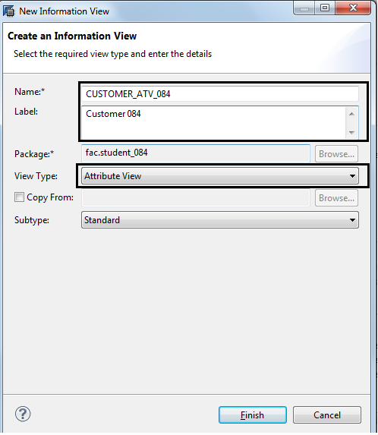

1. Add following tables to Data Foundation

**Tables**: **GBI_YYY.**CUSTOMER_ATTR_**YYY**,   
**GBI_YYY.**COUNTRY_CODE_DESC_**YYY,**

**GBI_YYY.**CUSTOMER_SEGMENT_ATTR_**YYY**.

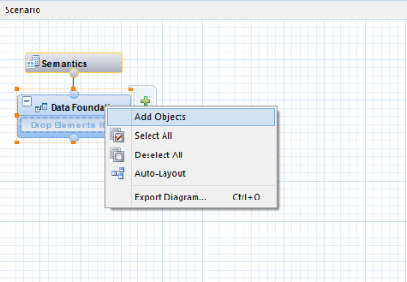

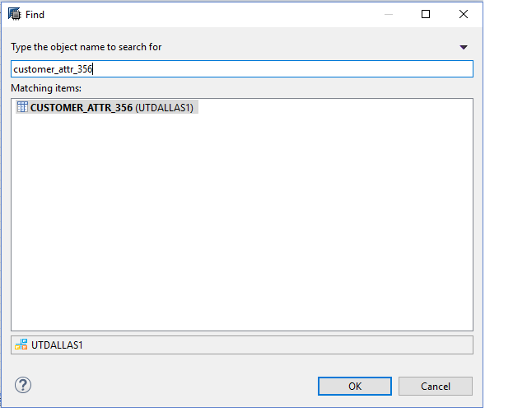

1. Similarly, add GBI_YYY tables for COUNTRY and CUSTOMER SEGMENT

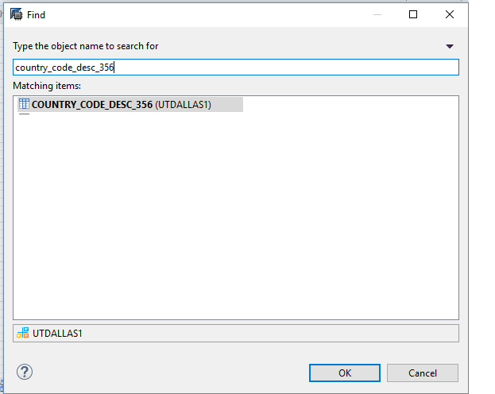

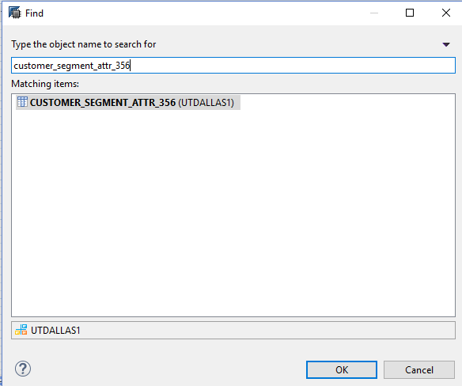

* 1. Join the table CUSTOMER_ATTR_YYY with table COUNTRY_CODE_DESC_YYY using a text join

To join the tables, you drag & drop the field COUNTRY of the Customer attributes table to the field country of the Country text table. Please be careful that you start with the Customer attributes table, as the first table that you use for the drag & drop represents the left table in your join.

You can set the join type and the language column for the text join in the properties section of the join.

The language column includes the language field of the text table. In this case, the language column is COUNTRY_CODE_DESC_YYY.LANGU.

Steps:

1. Drag & drop the field CUSTOMER_ATTR_YYY.COUNTRY_CODE to field

COUNTRY_CODE_DESC_YYY.COUNTRY_CODE.

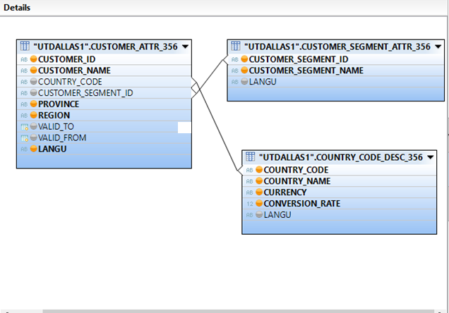

b. Click on the link between the two tables that represents the join. Now you should see the properties of the join on the right.

Adjust the properties as following:

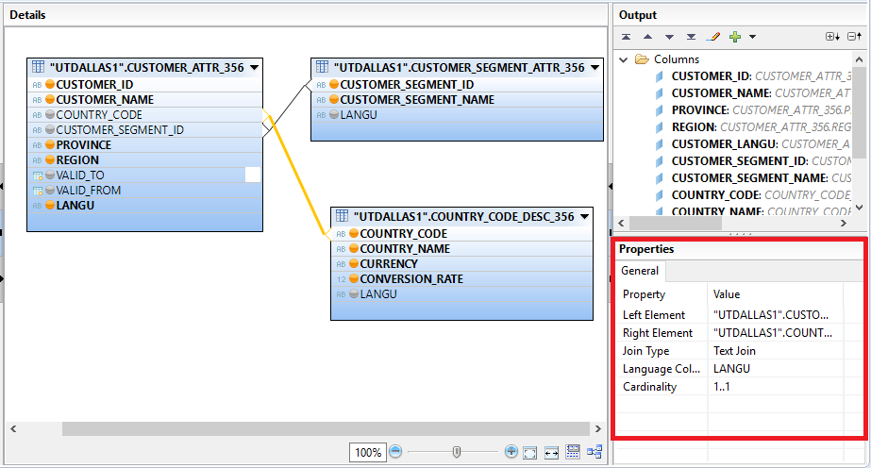

* 1. Join the table CUSTOMER_ATTR_YYY with table CUSTOMER_SEGMENT_ATTR_YYY using a text join

Steps:

1. Drag & drop the field CUSTOMER_SEGMENT_ID from the customer table to field CUSTOMER_SEGMENT_ID of table CUSTOMER_SEGMENT_ATTR_YYY.



1. Click on the link between the two tables that represents the join. Now you should see the properties view for the join in the bottom.

Adjust the properties as following:

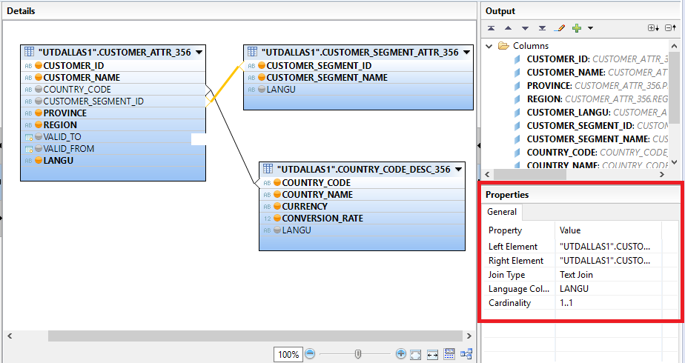

3.5 Question

Paste the screenshot of join created with properties:

Customer to Country Join:

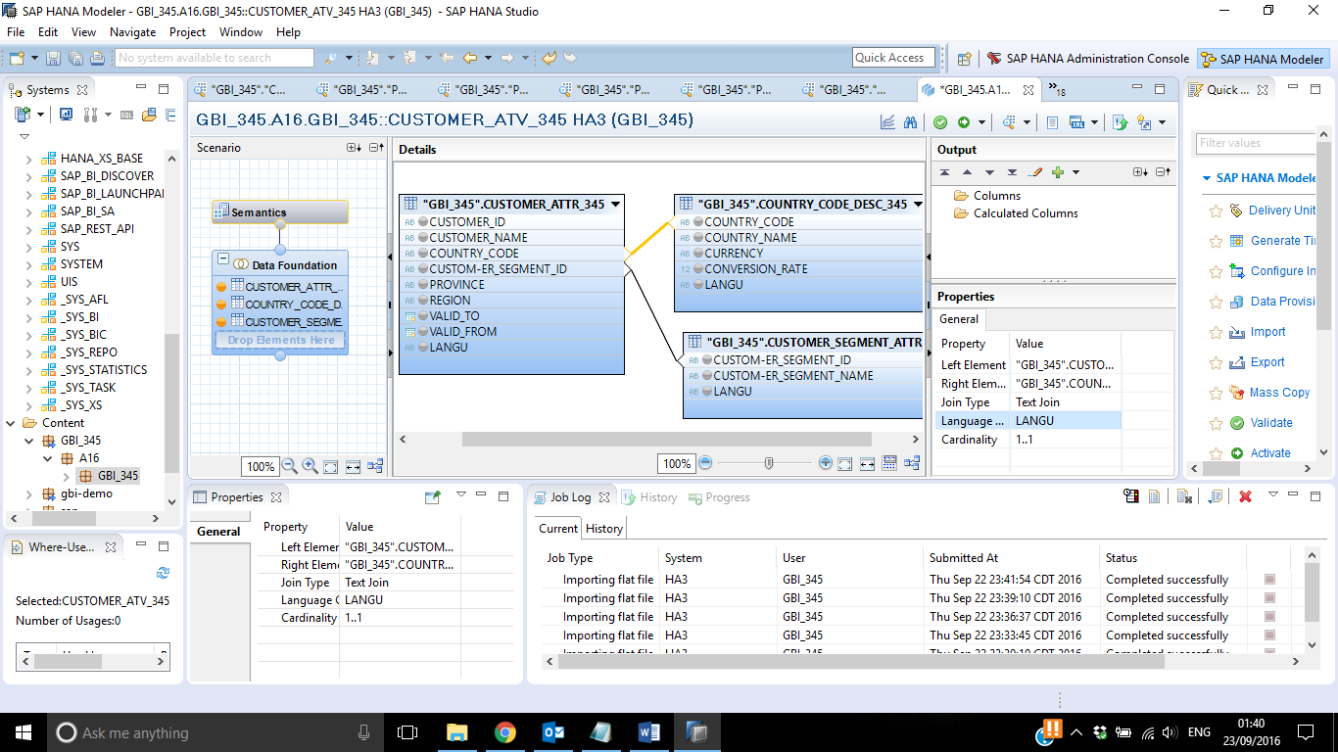

Customer to Customer Segment Join:

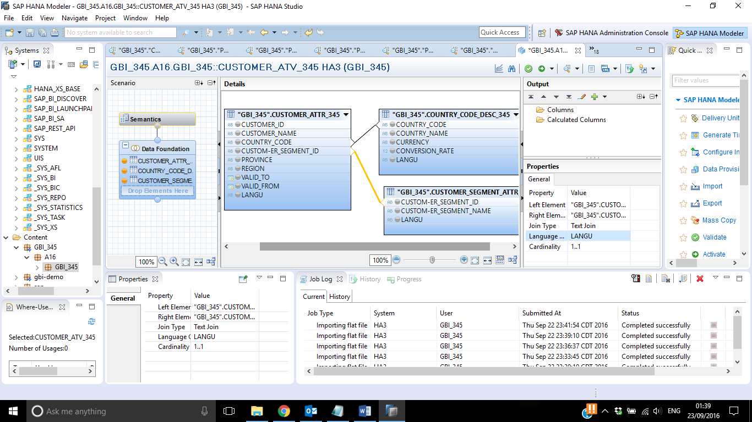

* 1. The view should show only current customers. For current customers, the valid-to date is equal to 9999-12-31. Add a corresponding filter to your view.

Hint: Select the VALID_TO field in the customer table and apply the filter. Please be careful that you enter the filter value in the right format (9999-12-31).

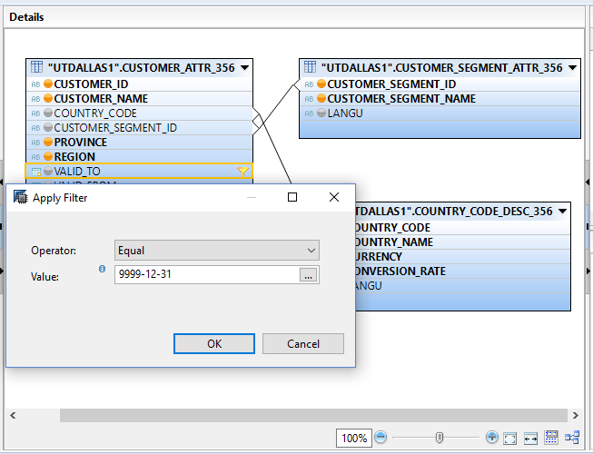

* 1. Add all attributes that should be visible in this view to the output structure

Hint: The output structure is visible on the right hand side.

Add following fields as attribute to the output structure:

|  |  |  |
| --- | --- | --- |
| **Table** | **Field** | **Key attribute** |
| CUSTOMER_ATTR_YYY | CUSTOMER_ID | **X** |
| CUSTOMER_ATTR_YYY | CUSTOMER_NAME |  |
| CUSTOMER_ATTR_YYY | PROVINCE |  |
| CUSTOMER_ATTR_YYY | REGION |  |
| CUSTOMER_ATTR_YYY | LANGU |  |
| COUNTRY_CODE_DESC_YYY | COUNTRY_CODE |  |
| COUNTRY_CODE_DESC_YYY | COUNTRY_NAME |  |
| COUNTRY_CODE_DESC_YYY | CURRENCY |  |
| COUNTRY_CODE_DESC_YYY | CONVERSION_RATE |  |
| CUSTOMER_SEGMENT_ATTR_YYY | CUSTOMER_SEGMENT_ID |  |
| CUSTOMER_SEGMENT_ATTR_YYY | CUSTOMER_SEGMENT_NAME |  |

Select the table field that should be visible in the output structure.

Click on Add To Output.

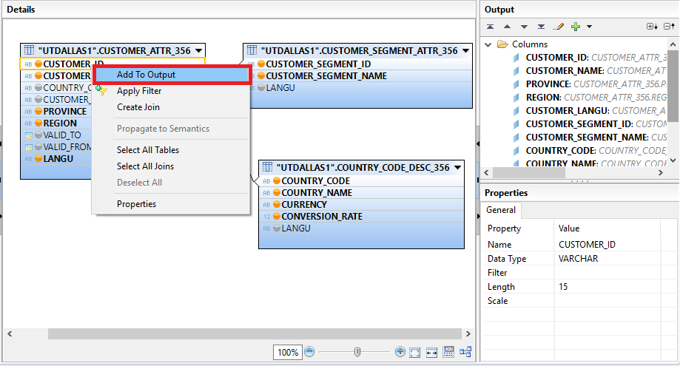

Now the field should be visible in the output structure.

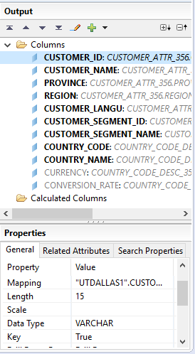

Repeat this for each table field that should be visible in the output structure.

Select True for the property Key Attribute to mark an attribute as a key.

* 1. Rename LANGU output column and hide CURRENCY AND CONVERSION_RATE columns in Output structure.

Objective of renaming the LANGU column is not to have conflict with product LANGU when we create an analytic view combining both the attribute views.

1. **Hint**: Click on the LANGU column in output structure and rename the output field to CUSTOMER_LANGU.

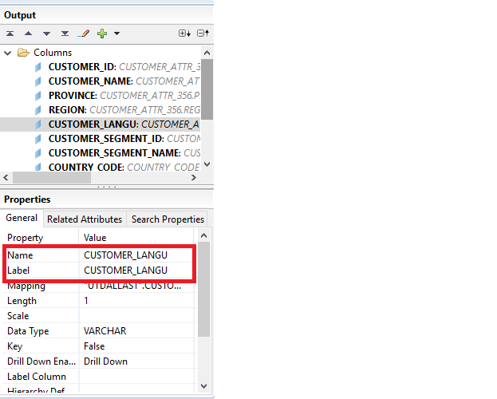

Objective of hiding the CURRENCY and CONVERSION_RATE column is to use them for calculation purpose and not to make them visible in the output.

1. **Hint**: Click on the CURRENCY column in output structure and make the hidden property as true. Similarly, do it for CONVERSION_RATE.

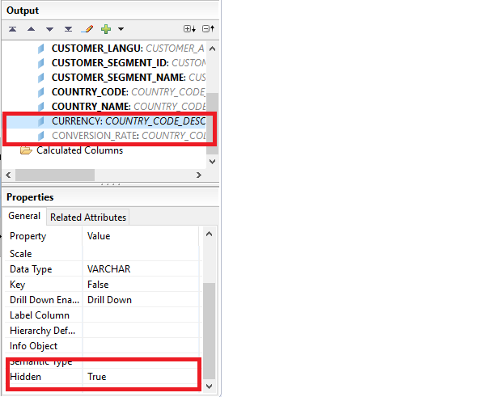

**3.9 Question:**

**Paste the screenshot of your screen:**

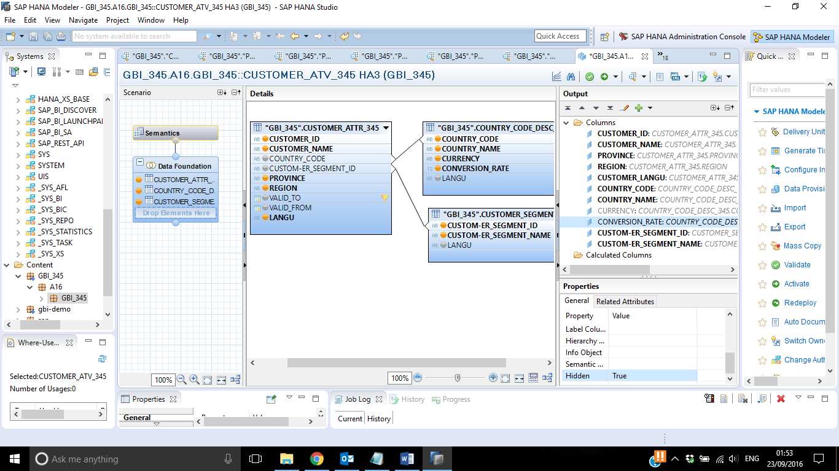

* 1. Save, validate and activate the view

Press Save and Validate.

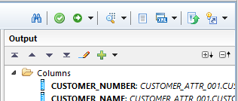

Check the Job Log. In case of an error, the job is highlighted in red.

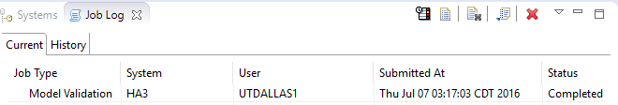

3.11 Press Save and Activate.



3.12 Question:

Paste the screenshot of the Job log:

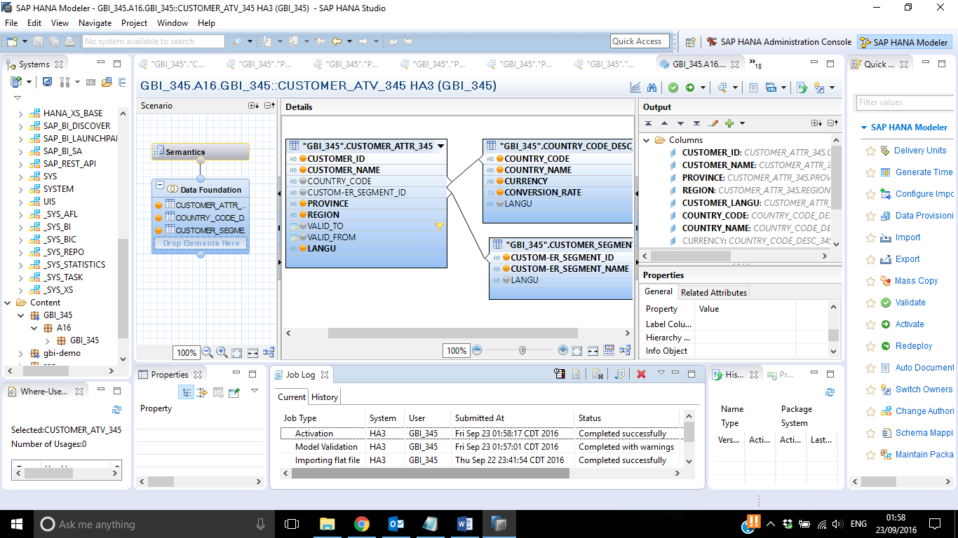

1. Create an attribute view for product data

You create an attribute view that includes product data.

The attribute view should show all product attributes except the price.

* 1. Create a new attribute view for the product data in your package

Steps:

1. Navigator View

Content → Package SXX.GBI_YYY → Right click → New → Attribute View…

1. Fill in the details:

View name: PRODUCT_ATV_YYY

View description: Products YYY

Tables: PRODUCT_ATTR_YYY,

PRODUCT_LINE_ATTR_YYY,

PRODUCT_CATEGORY_ATTR_YYY,

PRODUCT_SUBCATEGORY_ATTR_YYYY

Add all these tables to Data Foundation one by one as you did in step 3.4.

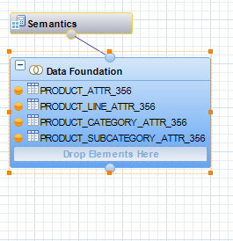

* 1. Join the table PRODUCT_ATTR_YYY with tables PRODUCT_LINE_ATTR_YYY, PRODUCT_CATEGORY_ATTR_YYY, PRODUCT_SUBCATEGORY_ATTR_YYY using a text join (Similar to what you did for Customer).

Steps:

1. Drag & drop the field PRODUCT_ATTR_YYY.PRODUCT_LINE_ID to field

PRODUCT_LINE_ATTR_YYY.PRODUCT_LINE_ID.

1. Click on the link between the two tables that represents the join. Now you should see the properties of the join on the right.

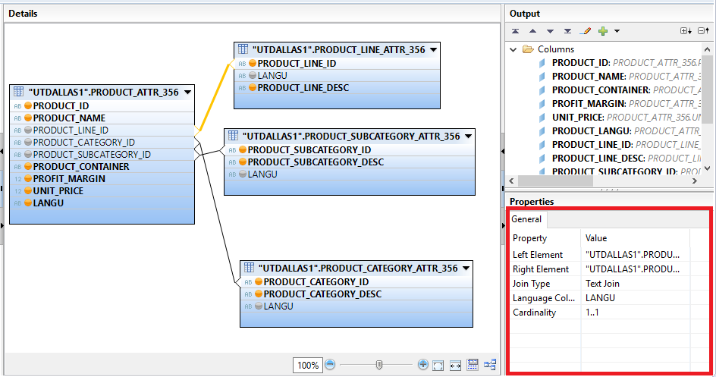

1. Drag & drop the field PRODUCT_ATTR_YYY.PRODUCT_CATEGORY_ID to field

PRODUCT_CATEGORY_ATTR_YYY.PRODUCT_CATEGORY_ID.

1. Click on the link between the two tables that represents the join. Now you should see the properties of the join on the right.

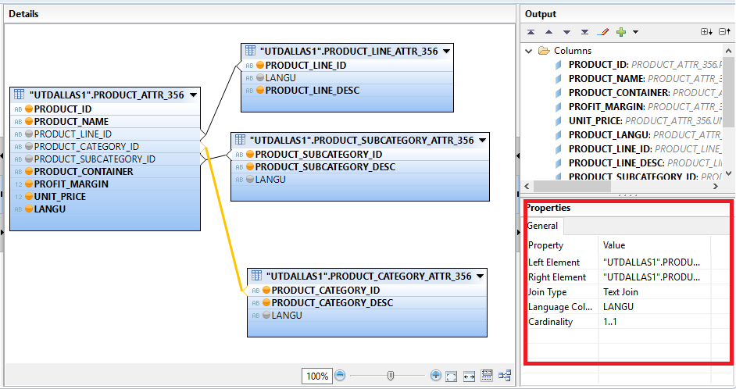

1. Drag & drop the field PRODUCT_ATTR_YYY.PRODUCT_SUBCATEGORY_ID to field

PRODUCT_SUBCATEGORY_ATTR_YYY.PRODUCT_SUBCATEGORY_ID.

1. Click on the link between the two tables that represents the join. Now you should see the properties of the join on the right.

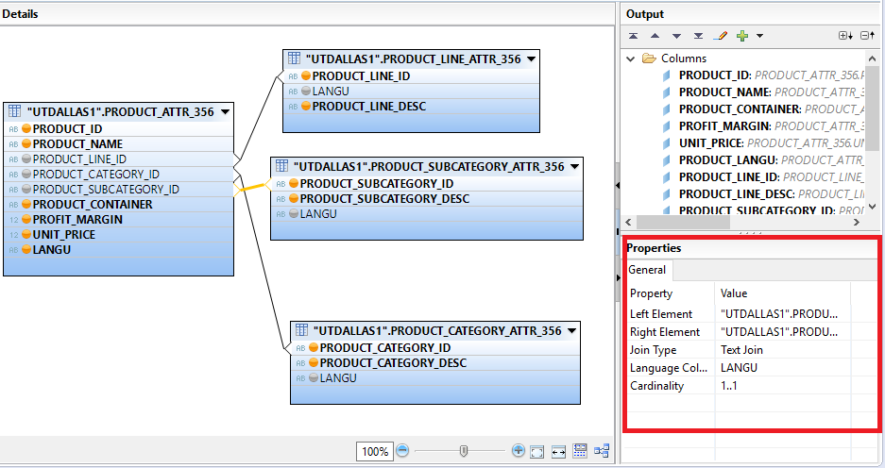

* 1. Add all relevant attributes to the output structure of the view

|  |  |  |
| --- | --- | --- |
| **Table** | **Field** | **Key attribute** |
| PRODUCT_ATTR_YYY | PRODUCT_ID | **X** |
| PRODUCT_ATTR_YYY | PRODUCT_NAME |  |
| PRODUCT_ATTR_YYY | PRODUCT_CONTAINER |  |
| PRODUCT_ATTR_YYY | PROFIT_MARGIN |  |
| PRODUCT_ATTR_YYY | UNIT_PRICE |  |
| PRODUCT_ATTR_YYY | LANGU |  |
| PRODUCT_LINE_ATTR_YYY | PRODUCT_LINE_ID |  |
| PRODUCT_LINE_ATTR_YYY | PRODUCT_LINE_DESC |  |
| PRODUCT_CATEGORY_ATTR_YYY | PRODUCT_CATEGORY_ID |  |
| PRODUCT_CATEGORY_ATTR_YYY | PRODUCT_CATEGORY_DESC |  |
| PRODUCT_SUBCATEGORY_ATTR_YYY | PRODUCT_SUBCATEGORY_ID |  |
| PRODUCT_SUBCATEGORY_ATTR_YYY | PRODUCT_SUBCATEGORY_DESC |  |

Select True for the property Key Attribute to mark an attribute as a key.

Select the table field that should be visible in the output structure as attribute.   
Click on *Add To Output*.

After adding all relevant fields, the output structure should look as following:

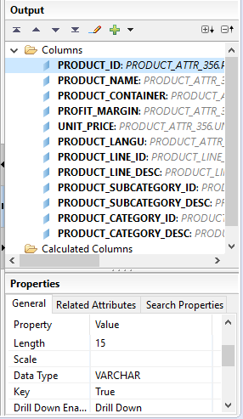

* 1. Rename LANGU output column in Output structure.

Objective of renaming the LANGU column is not to have conflict with Customer LANGU when we create an analytic view combining both the attribute views.

**Hint**: Click on the LANGU column in output structure and rename the output field to PRODUCT_LANGU.

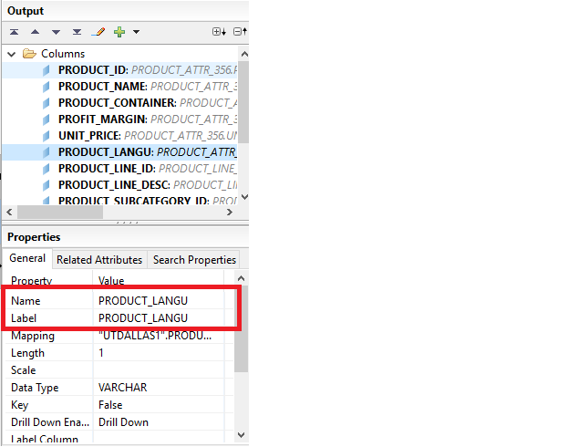

4.5 Question

Paste the screenshot of the attribute create along with properties:

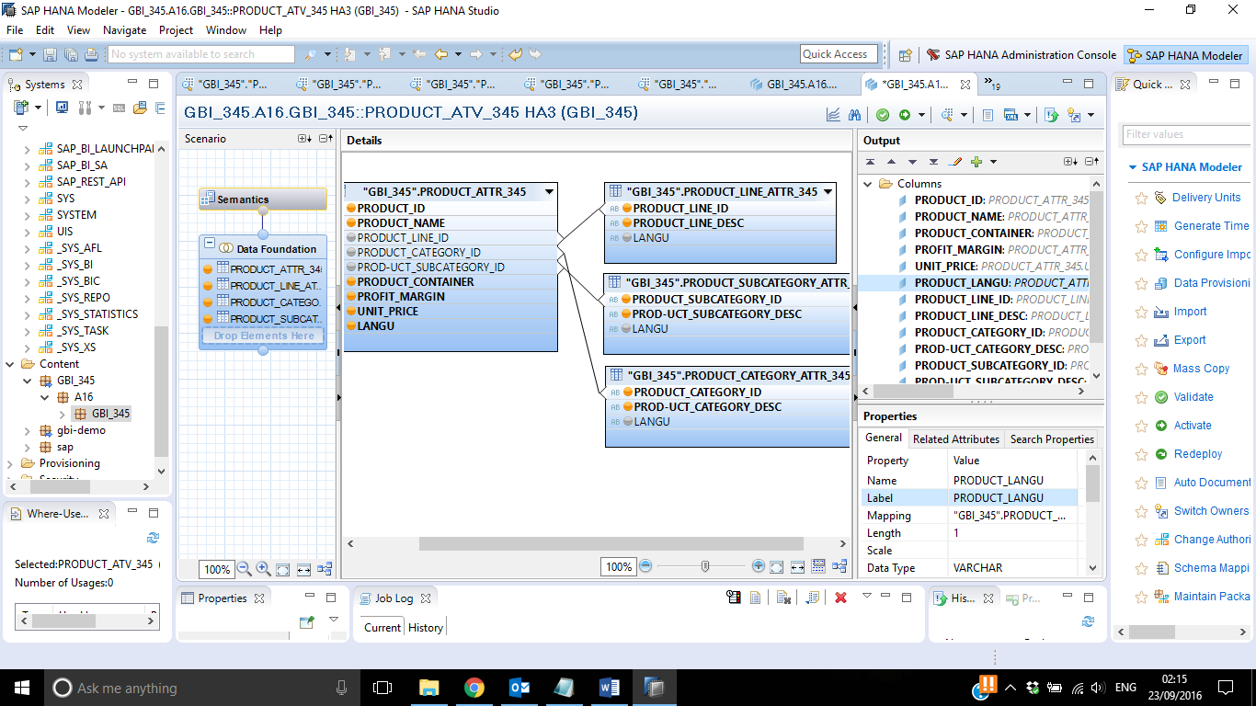

* 1. Save, validate and activate your view

Press Save and Validate.

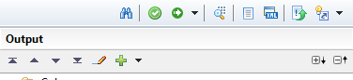

Check the Job Log. In case of an error, the job is highlighted in red.

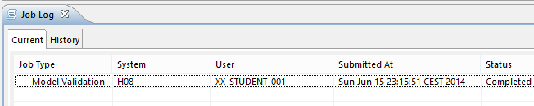

Press Save and Activate.

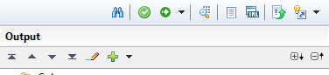

Check the Job Log. In case of an error, the job is highlighted in red.

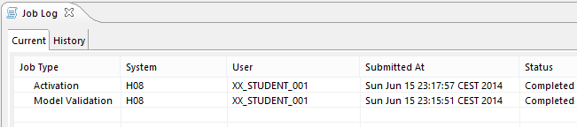

*Paste the screenshot of the Job log:*

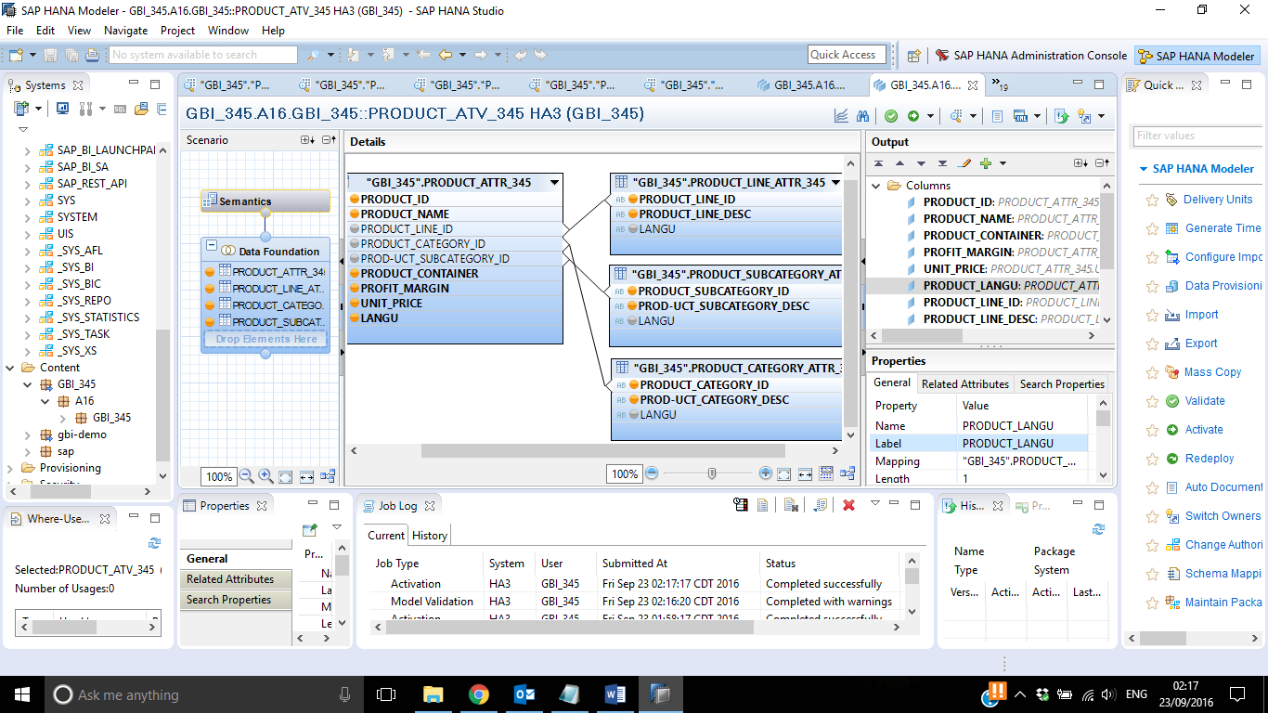

1. Let us do some basic reporting in HANA studio on these attributes.
2. Navigator View → Content → SXX.GBI_YYY → Attribute Views → CUSTOMER_ATTR_YYY → Right click→ Open Data Preview.

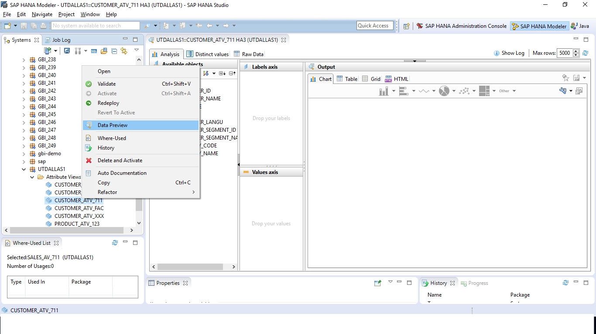

1. Open the Distinct tab and click on CUSTOMER_SEGMENT_NAME.

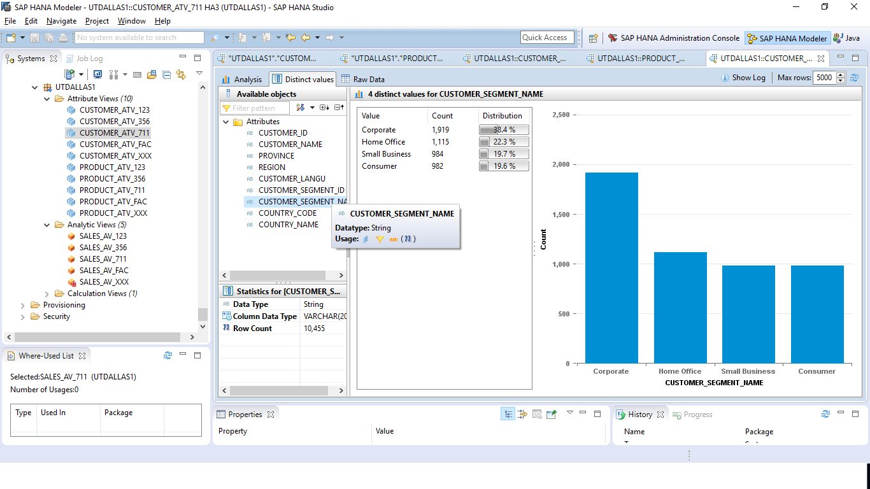

1. Paste the screenshot:

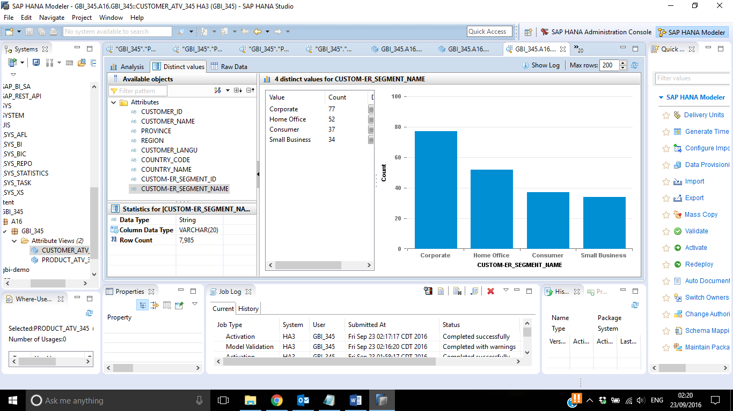

1. Select the Analysis Tab. Drag & drop CUSTOMER_SEGMENT_NAME in Label axis and CUSTOMER_ID in Values axis.

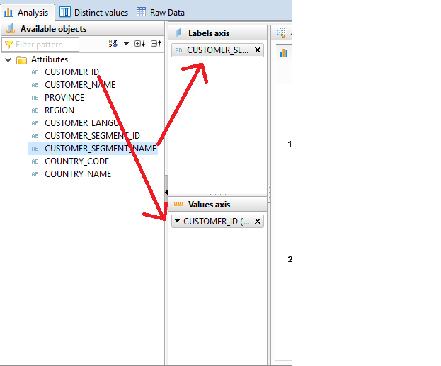

1. Select a Pie chart.

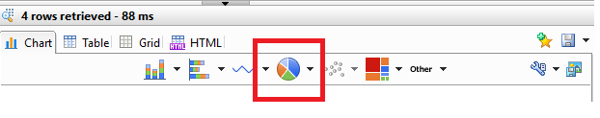

1. Paste the screenshot:

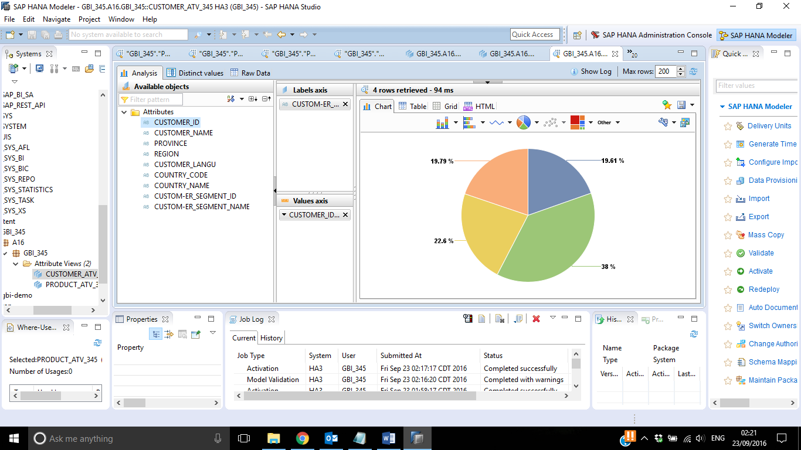

1. Navigator View → Content → SXX.GBI_YYY → Tables → PRODUCT_ATTR_YYY → Right click→ Open Data Preview.
2. Click on Analysis Tab. Drag & drop PRODUCT_CATEGORY_DESC in Label axis and PRODUCT_CONTAINER in Values axis.

Note: Product container signifies the size of the shipping box that carries the order placed.

1. Select a bar chart.

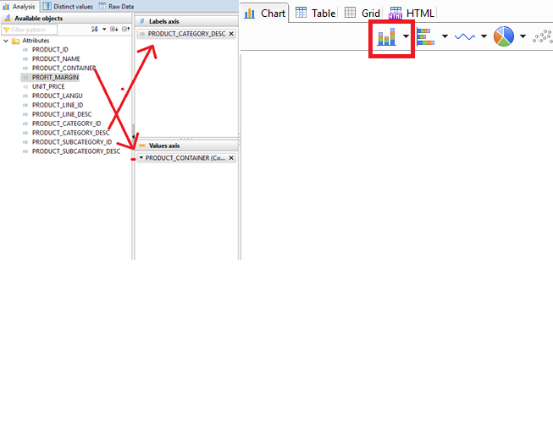

1. Click on the downward arrow right next to PRODUCT_CONTAINER in Values axis and select Sort ascending.

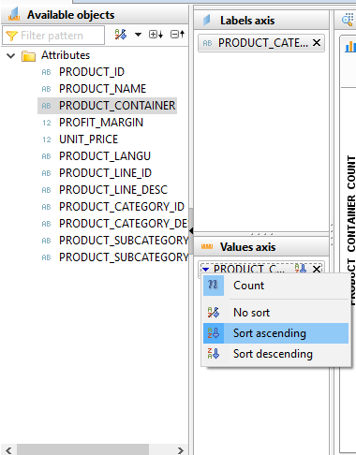

Paste the screenshot: